ESS 326 Geomorphology Name: ____________________________
Lab 4: Landsliding and the Factor of Safety
Due: Beginning of lab 5

The safety factor equation allows us to determine the danger of slope failure for the conditions of a particular hillslope. This equation states that the factor of safety (FS) is equal to the ratio of the resisting forces (shear strength) to the driving forces (shear stress). In the simple case of a slide plane on a hillslope without lateral boundary conditions (an "infinite slope"), the equation is:

$$FS=\frac{shear strength}{shear stress}=\frac{C+g*d*\cos{θ}*\left(ρ_{s}-h/d*ρ_{w}\right)*tan\left(φ\right)}{ρ_{s}*g*d*\sin\left(θ\right)}$$

C = cohesion (kPa = 1000 kg m⁻¹ s⁻²)
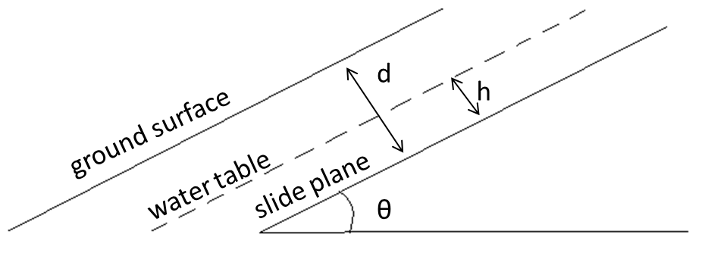
ρ_{s} = bulk density of hillslope material (kg m⁻³)
ρ_{w} = density of water = 1000 kg m⁻³
g = acceleration due to gravity = 9.81 m s⁻²
θ = slope angle of failure plane
h = water depth normal to failure plane
d = depth normal to failure plane
ϕ = internal friction angle of hillslope material

When shear stress equals or exceeds the shear strength of the slope, i.e. the FS ≤ 1, the slope is considered to be unstable and is bound to fail, sooner or later. NOTE: This equation is a MODEL for slope stability. This model is only valid for angles less than ~60°. Failure of steeper slopes tends to occur by toppling rather than sliding.

Constructing the Excel spreadsheet

We could calculate FS by hand, but doing this calculation in Excel allows us to quickly change parameters. We will also learn how to use a very powerful function within Excel: the Solver.

1. Enter in the following information into a spreadsheet into the rows and columns indicated:

 | A | B | C | D
1 | Symbol | Value | Units | Explanation
2 | Co |  | kPa | cohesion (1 kPa = 1000 kg m-1 s-2)
3 | rho_s |  | kg m-3 | bulk density of hillslope material
4 | rho_w | 1000 | kg m-3 | density of water
5 | g | 9.81 | m s-2 | acceleration due to gravity
6 | theta |  | degrees | slope angle of failure plane
7 | d |  | m | thickness of material normal to failure plane
8 | h |  | m | height of water normal to failure plane
9 | phi |  | degrees | internal friction angle of hillslope material

One at a time, select each of the cells in the Value column (even if empty) and choose from the tabs at top:
Formulas > Define Name > (For MS Office 2003 and earlier: insert > name > define > ) type the name to the left of the number > OK. Your next few calculations will say, “#NAME?” or “#DIV/0” until you finish putting values in later.

2. Calculate shear strength: In cell A11 type “shear strength =,” and in cell B11 type:

=1000*Co+g*d*cos(radians(theta))*(rho_s-(h/d)*rho_w)*tan(radians(phi))

3. Calculate shear stress: In cell A12 type “shear stress =,” and in cell B12 type:

=rho_s*g*d*sin(radians(theta))

4. Finally, calculate the factor of safety. In cell A13 type “FS =,” and in cell B13 divide the shear strength by the shear stress (i.e., type in “=B11/B12”). Because you haven’t finished entering values you won’t get an answer just yet.

Assignment:
1. Let’s investigate a typical hillslope in the western Olympic Mountains. The soil is sandy and therefore has practically no cohesion (Co = 0). The angle of internal friction for the material (ϕ or phi) is 35° and its bulk density (ρ_{s} or rho_s) is 2000 kg m⁻³. The slope fails as a slab 1.0 meter thick. There has been little rain and the material is dry (i.e. the water table is below the failure plane). Use your spreadsheet to calculate the maximum stable slope (“angle of repose”) for these conditions. Compare this slope to the angle of internal friction for this material. Does this relationship make sense? Explain.

Notice how you had to experiment with values of theta to give you a FS = 1. Excel has a function called the “Solver” that will do the iterating for you and calculate the theta required to give you a FS = 1.

Steps to use the Solver:
- Enter an initial guess for theta into the values column (any angle between 1 and 89 should work for an initial guess).
- Highlight the cell with the final calculation of FS (B13).
- For MS Office 2003 and earlier, go to the “Tools” menu and choose “Solver…”.
For MS Office 2007 and later, select the Data tab > Analysis > Solver. Note: if “Solver…” does not appear in the “Analysis” menu, click the office button (upper left) and select "Excel Options" then "Add-ins". Under the "Manage" box, select "Excel Add-ins" and click "Go", then select the solver check box and click OK
For MS Office 2010, select the Data tab > What-if-Analysis > Goal Seek.
- In the “set target cell” (“set cell” for 2010) box, enter “$B$13” or click on cell B13.
- Next to the words “equal to” (“to value” for 2010), click the dot for “Value of:” (don’t have this option in 2010) and type the number 1 in the box.
- Under the words “by changing cells,” type “theta”.
- Now click on the Solve box (or Ok for 2010). Excel will now automatically adjust the theta value (the “changed cell”) until the value for FS = 1 (the “target cell”). Excel will then let you know if it was successful or not. For various reasons, the Solver will sometimes be unable to converge on an answer. Each time you run the Solver, make sure to check whether FS = 1.

Use the solver to re-calculate the answer for 1. Spend a few seconds experimenting with initial guesses for theta; they should all converge to the answer you got above.

2. Now let’s explore the relationship between water level and slope stability. Keeping d = 1, find the critical slope (theta) for values of h ranging from 0 (totally dry) to 1 (totally saturated), at 0.1 m increments. Make a graph of the relationship between water level and maximum stable slope and print it out to turn in with this lab. What is the general effect of raising the water table on slope stability?

3a. In a catchment with hillslopes ranging from 5° to 35°, under what saturation conditions are there likely to be the most slope failures? Where would the failures occur, and why?

3b. Storms can rapidly raise the water table, changing the value of (h/d) in our slope stability equation. What might you expect the relationship to be between the size of a storm and the number of landslides?

4. Look at the color-coded map of slope angles for the Queets River catchment in the Olympic Mountains. Given your calculations, and the fact that this is a temperate rainforest, what is peculiar about the topography shown on this map?

5. The slopes in the Queets watershed are forested and the tree roots increase the soil cohesion from zero to about 10-15 kPa. Assuming a typical partial saturation condition of h = 0.3, and d = 1, can you find an unstable slope (between 0 and 60º) for this range of cohesion values? Does this recalculation explain the peculiar topography that you observed in question 4? Note: You may have to change the slope values manually, rather than by using the solver.

6. Identify the slope value that looks most common in the Queets Basin map (aside from the flat river plains), then use the solver to find the critical water table value (h). The exact slope value is not important, but it must be reasonable. Use a cohesion value (C) of 10 kPa and a soil mantle (d) of 2 m. Enter your slope value (theta) in cell B6. No highlight cell B8 and use the solver as before. What does this imply about the plant / soil interaction?

7. Logging reduces trees to stumps, which in turn reduces the soil cohesion from >10 kPa back down to about 2 kPa as the roots decompose. Using the same soil mantle and a water table value (h) of 1 m, calculate a critical slope for cohesion values (C) of both 10 and 2 kPa and write it below. Based on this calculation and your answers for questions 5 & 6, what do you suppose happens when you log hillsides like those in the Queets watershed?

8. Look at the map of Seattle Landslide Risk Areas:
http://pubs.usgs.gov/of/2000/ofr-00-0303/plate1.html
On this map, the blue band represents the contact between two glacial deposits: the Lawton Clay (below) and the Esperance Sand (above). Describe where landslides are most likely to occur in Seattle in terms of the topography and the geology. How does the unique geology of Seattle contribute, beyond just slope, to landslide risk? In particular, write about how this geology relates to the parameters we’ve been investigating (cohesion, h/d).

