Chapter 8 – Coastal and Marine Geomorphology
Incoming wave trains shoaling, breaking, and causing seacliffs to erode between Santa Cruz and Moss Beach, California. Photo by M. Miller. GEOMORPH0000001291.

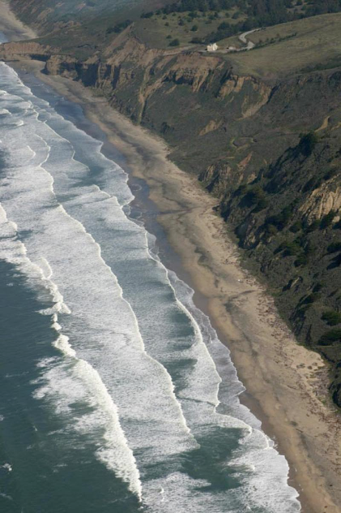

Introduction
Coastal Settings and Drivers
Substrate and Sediment supply
Tides
Waves
Coastal Processes and Landforms
Rocky coasts
Beaches
Spits, Barrier Islands, and Lagoons
Tidal Flats and Marshes
Estuaries and Deltas
Marine Processes and Seascapes
Continental Margins
Abyssal Basins
Mid-Ocean Ridges
Trenches
Applications
Introduction
Oceans cover most of Earth’s surface, and more than half of Earth’s human population lives within 40 kilometers of the shoreline where land meets the sea. Coastal environments have long been important for human societies, providing sheltered ports, resource-rich estuaries, and beaches for recreation. Today, however, coastal areas are particularly vulnerable to change in a warming world with rising sea levels. But the 70% of our planet that already lies beneath the waves is important in its own right. Earth history is, for the most part, recorded in marine sediments. Unlike terrestrial environments that erode over time, marine environments accumulate sediment that builds up the rock record over time, although only a portion gets preserved due to subduction recycling of most oceanic crust. Continental margins are economically important because many oil and gas deposits form and are found in modern and ancient marine environments. Sea-floor topography (bathymetry) — the dominant type of topography on the planet — is hidden from direct observation by water but can be studied using geophysical images and seafloor sampling techniques. We interpret seafloor geomorphology using the same general principles of regional context, conservation of mass and energy, and boundary conditions that guide our interpretation of subaerial landforms.
Coastal environments receive sediment delivered by stream systems that has been eroded from continental landscapes, and define a transitional zone from terrestrial to marine processes. Unlike rivers, where water only flows one way — downhill — coastal and estuarine environments are subject to bi-directional flows from rising and falling tides and waves washing back and forth. The interaction of waves, currents and tides results in alongshore sediment transport, coastal erosion, and local deposition that shape coastal landforms. Sediment deposition and wave action over glacial-interglacial cycles of rising and falling sea level have created continental shelves across which sediments are delivered to the ultimate sediment sink — the deep marine environment. Sea-level changes greatly affect coastal sediment dynamics, with large amounts of sediment trapped in estuaries and embayments when sea-level is rising. This chapter explains the fundamental processes and major landforms of coastal and marine environments.

Coastal Settings and Drivers
Coastal morphology is broadly determined by tectonic setting, although over time changing sea level is an important control on margin morphology and process. The geometry of a continental margin depends in great part on whether it occurs in the middle or on the edge of a tectonic plate (Figure 8-1A). Convergent and transform margins are active margins, where the edge of the continent coincides with where two tectonic plates collide. In these settings, continental and oceanic crust move toward or slide past each other across the continental margin, resulting in active rock uplift. Subduction zones typically have a coastal mountain range hosting volcanoes and earthquakes (where denser oceanic lithosphere sinks beneath a lighter continental plate), or volcanic island arc (where subduction involves two oceanic plates). Both types of subduction zone typically have a narrow continental shelf that leads out to a continental slope that drops steeply to a deep submarine trench. Ocean-continent subduction zones around much of the Pacific Ocean, including the coast of the Pacific Northwest, are typical examples of subduction zones. Convergent margins tend to have well-developed, rocky coastlines that are dominated by erosional landforms (Photo 8-1A), though deltaic and other coastal depositional landforms sometimes develop near significant sediment sources, such as the Columbia River on the border of Oregon and Washington.
In contrast, a passive margin (or trailing edge margin) is one where the continental margin does not coincide with a plate margin. Consequently, the oceanic and continental crust move in the same direction and speed. Most trailing-edge margins have an exposed coastal plain, part of which was continental shelf during higher sea level stands. Similarly, the modern continental shelf was the coastal plain during lower sea level stands. The eastern continental margin of North and South America, the margins of Africa and the Gulf of Mexico coast, are examples of trailing-edge margins. Trailing-edge margins typically have extensive depositional landforms that are built by sediment transport and storage along the coast (Photo 8-1B).
The salinity and temperature of seawater are fundamental drivers of coastal and marine processes. Ocean water has approximately 35 parts per thousand (ppt) of salt dissolved in it. For comparison, fresh water in lakes and rivers typically contains less than 0.5 ppt of dissolved mineral material. Brackish water in estuarine environments can have variable salinity but often is around 20 – 30 ppt. Lower salinity translates to lower density, so plumes of river water float on denser salt water where rivers enter coastal and marine environments. In some cases, however, high concentrations of suspended sediment increase the density of the water and create bottom-hugging density currents that cause erosion, displacement, and deposition of sediments in deep marine environments well below the depths affected by wave attack. Gradients in temperature and salinity drive circulation of deep ocean currents.
The volume of water in Earth’s interconnected oceans also plays a major role in coastal dynamics and evolution. Shoreline positions adjust to changes in sea level relative to a particular coast. When sea level rises, the shoreline advances landward. Falling sea level causes the shoreline to retreat seaward. Sea level changes can be worldwide, or eustatic, fluctuations in the global volume of the oceans, steric changes caused by fluctuations in ocean temperature or salinity, or local changes in relative sea level caused by isostatic or tectonic uplift or subsidence of a particular coastline.
Eustatic sea level is closely tied to the amount of glacial ice on land, and on the thermal expansion and contraction of ocean water. Sea level falls when a glaciation begins and the ice volume at the poles grows. This leads to marine regression as coastlines migrate seaward and fluvial systems extend to reach the sea while cutting down into the coastal plain to adjust to falling base level. Conversely, when glaciers melt and transfer water back into the oceans at the end of a glaciation, sea level rises and causes marine transgression during which shorelines move landward and seawater inundates formerly coastal areas. At the height of the last major glaciation, about 18,000 years ago, sea level stood about 130 m below its present level. It has been rising since then. During the most recent deglaciation, sea level rose about 1 cm yr⁻¹ until about 7,000 years ago, and then the pace slowed to less than 2 mm yr⁻¹ about 5,000 years ago. Sea level then stabilized about 3,000 years ago. Over long periods of geologic time, sea level varies through glacial-interglacial cycles and coastal processes act across a wide zone that ranges from several meters above today’s sea level to the now-submerged edge of the continental shelf.
The pace and timing of sea level change along any particular coast depends on several factors in addition to continental ice volume, including elevation changes due to tectonic uplift or subsidence, consolidation as sediments compact and sink under their own weight, and glacial isostatic rebound as the land rises after removal of the weight of glaciers during deglaciation. On the eastern seaboard of the United States sea level rise since the mid 20th century averaged about half a cm yr⁻¹.

Substrate and Sediment Supply
Like terrestrial landscapes, some coastal and marine environments are composed mainly of consolidated bedrock and others are composed of mostly unconsolidated materials. Emergent coastlines are stretches along the coast that have been exposed by relative sea level fall. Submergent coastlines are those that have been inundated by the sea due to a relative rise in sea level. Emergent coastlines and headlands are often composed of rock outcrops with far greater erosional resistance than submergent coastlines that are mostly made of unconsolidated sediment. This variability in erosional resistance and sediment supply creates strikingly different coastal features and causes different dynamics on rocky, erosional coasts than on depositional shorelines.
A variety of mechanisms bring sediment to coastal and marine environments, and the particular mix of processes that deliver, store, and remove sediment sets the sediment budget for specific coastal and marine environments (Figure 8-2). Sediment sources typically include rivers, coastal erosion, longshore drift, in situ growth of biogenic carbonates and aeolian inputs. In many coastal settings, stream systems that discharge into coastal and estuarine environments deliver the majority of sediment.
Once sediment is introduced to a coastal setting, it is generally transported parallel to the coast by longshore currents that are generated by waves approaching the shore at an oblique angle. In areas with limited sediment input from rivers and streams, coastal sediment supply typically is dominated by cliff erosion that delivers reworked glacial deposits or other unconsolidated material to coastal settings, or by carbonate-producing organisms like corals and shellfish that thrive in clear water away from fluvial inputs of clastic sediment. In modern, high-latitude environments and in many settings during past periods of cooler climate, glaciers and icebergs that calve off of tidewater glaciers deliver sediment directly to coastal and marine environments. Coastal sediment sinks include depositional environments like dunes and lagoons, as well as river deltas and carbonate platforms. The dominant sediment source in the deep ocean basins is steady deposition of the bodies of single-celled marine plants and animals that sink from the near-surface photic zone, plus the slow accumulation of wind-delivered dust. However, coarse-grained, clastic sediment from the continents does occasionally make its way down the continental slope and into the abyssal plains of the deep sea.

Tides
The daily rhythm of the tides is familiar to all who have spent time near the sea. The gravitational attraction of the Moon and Sun pulls the sea surface toward them and creates a bulge of ocean water; centrifugal force creates a second antipodal bulge on the other side of the planet (Figure 8-3). Most coastlines experience two equal tides per day as Earth rotates under the lunar and solar tidal bulges. Factors like local ocean bottom topography and coastal morphology, however, cause some areas to have two tides of unequal magnitude, and there are some coasts have just one high and low tide per day (diurnal tides).
The tidal range, the difference between the elevation of high and low tides, occurs when the gravitational fields of the Sun and Moon reinforce each other to create a higher-than-average spring tide. When the Moon and Sun are oriented at right angles and their gravitational attraction interferes with one another, it produces a lower tidal range called a neap tide. Consequently, tidal ranges vary over a 28-day period as the orientation of the moon and sun change during the moon’s orbital cycle. Spring tides are typically about 20% greater than average, and neap tides are usually about 20% less than average. Spring tides accompany the new and full moon each month, and low neap tides accompany the waxing and waning quarter moons. Each month there are two periods of spring tides and two periods of neap tides. Spring tides are important geomorphologically because they allow waves and wave energy to reach farther inland and erode shoreline features.
Tides generate currents that flow perpendicular to coastlines, in and out of bays and lagoons. Tidal flows have enough energy to prevent sediment accumulation and maintain tidal inlets and to force seawater into tidal channels in estuaries. The geometry of the seabed along specific coastlines often acts to increase or decrease local tidal ranges, so the effect of tidal flows varies from place to place. Constricted inlets can produce particularly dramatic tidal ranges, one famous example is the narrow inlet of eastern Canada’s Bay of Fundy that has an extreme macrotidal range of 15 m. Macrotidal coastlines experience tides greater than 4 m, mesotidal coasts experience intermediate tidal ranges between 2 and 4 m (as is common on the West Coast of the United States), and microtidal coasts like the those around the Caribbean Sea experience fluctuations of less than 2 m. Incoming and outgoing tides are often asymmetrical and uneven in strength, and they may roll around a bay rather than moving directly in and out. Rapidly advancing tidal fronts known as tidal bores push breaking waves into estuaries and rivers, and force saltwater inland. In the Amazon River, for example, the tidal bore pushes seawater and a tidal surge as much as 480 km inland. Combinations of high tides and high storm surges from storm-generated waves can produce unusually destructive tides.

Waves
Waves are the dominant driving mechanism for coastal processes, they govern erosion and sediment transport in coastal environments. Blowing winds impart energy to the sea surface as the two fluids, air and water, couple sufficiently that kinetic energy is transferred to the water. Over time, that energy becomes focused into discrete water waves. The factors that affect the formation of waves are 1) the duration of the wind event, 2) velocity of winds, and 3) the fetch, the distance that the wind blows across the water surface. Long duration, high velocity wind blows across a large area produces large, energetic waves that travel out from the area where they were generated. Fetch is particularly important in determining the characteristics of waves. Waves from large storms often cause dramatic changes in coastal environments, but the smaller waves that arrive day and night are the primary shapers of coastal landforms. Fair weather waves and the longshore currents they generate also act to progressively heal storm damage and reshape coastlines after storms.
Waves are described by several basic characteristics (Figure 8-4). Wavelength (L) is the distance between successive wave crests. Wave period (T) is the time it takes for two wave crests to pass the same point. Wave velocity (v) is given by the ratio of wavelength to wave period:
v = L / T 8-1
Wave height (H), or amplitude, is the vertical distance between a wave crest and its low point or trough, and thus equals the amplitude of the water surface rise and fall as a wave moves past a point on the sea surface.
Variable winds blowing across an area of the deep ocean surface during a storm event create waves with a wide range of wavelengths and different travel directions. This produces an irregular sea surface that is characterized by choppy, interacting waveforms known as a confused sea. Individual crests within the spectrum of waves generated by the event are only discernable for brief instances as out-of-phase small and large waves interfere with one another. However, waves with longer periods and wavelengths travel more quickly than smaller waves, so waves sort out by size as they travel. This process, known as wave dispersion, creates a pattern of well-defined waves that travel outward from the area of confused sea where they were generated. The longest wavelengths create swell, regularly spaced waves with low, gently rounded crests that can travel thousands of kilometers across the open ocean with little loss of their original energy — until they approach land. As flow shallows, pointed wave crests develop and then break to produce surf.
The water in a wave does not move with the wave. The propogation of energy imparted to the waveform causes the rhythmic rise and fall of the sea surface in which the wave moves forward, but the water does not. In deep water, water molecules oscillate near the sea surface, and move in circular orbits as a wave passes their location (Figure 8-5). The diameter of the orbit decreases with depth below the water surface, and drops off to produce no motion at a water depth greater than one half the wavelength, a depth referred to as the wave base. Below this depth, water molecules are undisturbed as waves pass over the surface. This is why the calmest place to ride out a storm at sea is in a submarine.
As waves approach the shore and enter water shallower than half their wavelengths, the bottom of the wave begins to interact with the seabed, which exerts drag on the water near the bed. The orbital paths of water molecules in the wave flatten and become elliptical, with the water and sediment at the seabed essentially just moving back and forth. Deeper shoreward flow under the wave crest moves more sediment than the shallower seaward flow under the wave trough, producing an asymmetry that causes net sediment transport toward shore.
Waves begin to feel bottom, or shoal, when the water depth decreases to less than the wave base (half the wavelength). When a wave begins to shoal and encounter bottom friction upon entering shallower water, wave speed decreases, wave height increases and wavelength decreases. This causes the wave crest to progressively steepen, and increases the ratio of wave height to wavelength (H/L). When H/L exceeds 1/7 (i.e., when wave height exceeds 0.14 times the wavelength) the wave crest loses support, becomes unstable and breaks, producing surf that dissipates potential energy as kinetic energy in the near-shore environment.
Differences in the velocity asymmetry beneath steep and gentle waves create different types of breaking waves. Beach steepness, which is largely determined by beach sediment grain sizes, also affects the type of breakers that develop on a particular beach. Gently sloping, fine sand beaches typically produce spilling breakers through which one can casually wade out into the sea (Photo 8-2a). The crest of a spilling breaker becomes unstable first and gradually cascades down the advancing wave front as irregular foam. Spilling breakers characterize beaches along the Southeastern Atlantic and Gulf of Mexico coasts of the United States. In contrast, plunging and surging breakers more attractive to surfers are generally found along steeper beaches composed of coarse sand and gravel. Plunging breakers curl over the front of the advancing wave and fall onto the base of the wave over a short distance, producing a turbulent mass of water that churns up and suspends bottom sediment. (Surfers call the tunnels of air under the curling crests of plunging breakers pipelines.) (Photo 8-2b). Surging breakers maintain unbroken wave crests as they run up the shore (Photo 8-2c). They typically develop where low, flat waves approach steeply sloping beaches, and waves shoal very close to the shoreline. Development of the different types of breakers also depends on the wave height, wavelength, and wave period, so there is an ever-shifting variety of waves that attack a particular shoreline.
The surf zone extends from the seaward limit of breakers to the landward extent of waves that run up the beach face. The swash zone is the area that is covered by swash that runs up the beach face, and exposed after backwash flows back down the beach face. Alternation between vigorous swash and sluggish backwash often produces fine lamination in beach sands that is highlighted by striking layers of density-sorted minerals.
As waves shoal and break, they erode material from the seabed. Fine-grained silt and clay are transported seaward in suspension, while waves move coarser sand (and gravel on high energy beaches) back and forth on the seabed, producing net shoreward transport. This oscillatory action sorts sediment grains and creates beaches that are composed of bedload material. the size of which reflects wave energy. Swash carries sediment up the foreshore and backwash moves it back down toward the sea. Swash moves up the beach in the direction the wave was traveling. In contrast, backwash is pulled back into the sea by gravity, and moves directly down the slope of the foreshore, orthogonal to coastline. Because waves typically approach the shore at an angle, a zig-zag pattern of sediment transport during swash and backwash produces littoral or longshore currents that move sediment, called longshore drift, along the shoreline (Figure 8-6). The direction of longshore currents, and thus that of longshore drift, is governed by the prevailing direction at which waves strike a coastline.
Where waves approach land at an angle to the shoreline, the shoreward ends of the waves reach wave base and begin to shoal before the seaward ends. This produces an effect known as wave refraction that bends the wave crests in response to the near-bottom portion of a wave traveling progressively slower upon moving into shallower water (Photo 8-3). Wave refraction along irregular coastlines concentrates erosive energy on headlands that project out into the sea, and promotes deposition in protected embayments. Promontories become the focus of erosion, and protected coves become the focus of sedimentation. Thus, wave energy acts to straighten coastlines over time. Longshore currents produce net transport along a coastline, so material delivered to coastal environments moves parallel to shore, nourishing beaches until it is transported offshore to deeper marine environments below the wave base.
Human structures in coastal environments often have profound effects on longshore sediment transport. Groins project from a shoreline into the sea (Photo 8-4a). Because they intercept sediment moving along the coast, sediment accumulates on the up-current sides of groins and erosion cuts away the beach on their down-current sides. Jetties (barriers that project farther out into the ocean than groins) produce a similar effect, and lead to a zone of sediment accretion on their up-current side and a zone of erosion on their sediment-starved, down-current side (Photo 8-4b). Breakwaters that armor a shoreline or deflect longshore currents also change local patterns of erosion and deposition. Progressive beach erosion because of sediment starvation that results from shutting off or intercepting longshore transport is a major problem in many coastal areas.
In tectonically active regions, very large waves can wreak havoc on coastlines. Tsunamis are extremely long wavelength (typically 100 to 200 km), low amplitude (< 1 m) waves that are generated by sudden impulses, including earthquakes, submarine landslides and undersea volcanic eruptions. A tsunami can travel across an ocean and produce damaging effects on coastlines far from the earthquake that generated it. With wavelengths that exceed the depth of the ocean, tsunamis can travel at remarkable velocities (>500 km hr⁻¹) and catastrophically inundate coastal areas with little to no warning. Because tsunamis are often less than a meter high in open water, they are virtually impossible to notice at sea. But upon their arrival at a coastline, they can grow to produce waves more than 20 meters tall. As it shoals, a tsumami creates a large wave trough that produces what appears to be an anomalously low tide before the wave crest sweeps inland at devastating speed. Coastal configuration and the direction from which a tsunami strikes the coast affect the geometry of the waves and the pattern of coastal inundation at particular locations along a coastline. Like other types of waves, tsunamis interact with the coastal geometry as they approach land, and produce wave refraction and shoaling effects that similar to those that result from normal wave action, only much larger.
Another source of anomalously high waves is storm surge, which is produced by strong storm winds that push water shoreward into the coast, in combination with a bulge in the sea surface under the area of low atmospheric pressure at the storm. Storm surges can raise local sea level 2 to 5 m during hurricanes, and push water far inland in low-relief terrain. The additional temporary rise in local sea level because of storm surge amplifies the destructive impacts of hurricanes. For example, a storm surge of up to 7.6 m (25 ft) during Hurricane Katrina was a key factor in the catastrophic levee breaks that flooded the city of New Orleans in 2005.

Coastal Processes and Landforms
Coastal landforms reflect erosional and depositional processes as well as the grain size and volume of sediment available for transport in different environments. High-relief shorelines typically develop on tectonically active continental margins, where erosion of bedrock by wave action creates most coastal landforms, and beaches are small and isolated. Low-relief shorelines, in contrast, typically develop on passive margins adjacent to extensive coastal plains composed of unconsolidated, clastic sediment derived from the continental interior. Coastal landforms in such settings typically consist of depositional features produced by longshore transport and deposition of sand by wave action. Beaches are the primary coastal landforms most people know and love, but there are many other distinctive landforms along sandy and rocky coastlines, including tidal flats, estuaries, and deltas (Figure 8-7).
There are large differences in rates of coastal retreat, and advance, between sandy and rocky coasts due to differences in sediment supply and wave attack. Sandy coasts can advance if supplied with enough sediment. A falling sea level will also result in coastal advance (forming emergent coastlines), whereas a rising sea level pushes coastal processes and landforms inland (forming submergent coastlines). On eroding shorelines, coastal retreat may be very episodic; a coast retreating at an average rate of 1 m a century may retreat all at once during a single storm. Consequently, short-term rates of coastal retreat don't represent good predictors of long-term behavior. Big storms can produce short-term erosion on an advancing coastline or where lower long-term rates reflect generally low energy wave attack and erosion-resistant coastal materials.

Rocky Coasts
Sea cliffs that are produced by landward retreat of bedrock slopes undercut by wave action are the most common and striking feature of rocky coasts (Photo 8-5a). Active sea cliffs rise vertically from the shoreline at a sharp angle, and are maintained by wave erosion at their bases. Inactive sea cliffs that have been lifted above the zone of wave attack by tectonic uplift or isostatic rebound typically have a smoothly curving cliff base that has been shaped by subaerial weathering, erosion and mass wasting. In places where sea cliff bedrock is resistant enough to support an overhang, a wave-cut notch may develop at the base of the cliff (Photo 8-5b). Relict wave-cut notches at the bases of inactive sea cliffs record former shoreline positions on tectonically active coasts.
Landward sea cliff retreat occurs when wave erosion undercutting the cliff base leads to mass failure of the cliff face. If wave action and longshore currents are sufficient to remove the debris, the process repeats, and drives the cliff landward. The erosional resistance of the rock or sediment forming the sea cliff, the weathering processes acting to weaken the cliff face, and the energy and height of the waves striking the cliff base together determine the pace of cliff retreat. Sea cliff erosion rates of several meters per year can occur in unconsolidated material, but rates as low as a millimeter per year are more typical in erosion-resistant rocks like granite. Sea-cliff erosion typically does not occur under normal, fair-weather wave attack, but instead occurs during infrequent but powerful storms. Consequently, determining an average rate of sea-cliff retreat involves assessing erosion over decades or even centuries. Modern sea cliff retreat along uplifting coastlines is driven, in general, by an ongoing, post-glacial rise in global sea level. An additional 0.5 to 1.5 m of sea level rise that is projected to result from melting of polar ice over the next century will cause a general acceleration of sea cliff retreat, but the effect will vary locally depending on shoreline relief, sediment supply, beach slope, wave energy, and tidal range.
Wave action on rocky coasts also produces a wave cut platform that is beveled off just below the high-tide level (Photo 8-5b). Wave-cut platforms typically slope seaward at a gentle angle and serve as breakwaters that dissipate wave energy, and slow sea cliff erosion. Wave-cut platforms are maintained by a number of processes, including erosion from wave action, the abrasive effect of suspended sediment on the bedrock, and waves sweeping away the weathering products that result from mechanical and chemical disintegration of coastal bedrock that has been exposed to repeated wetting and drying in the surf zone. On actively uplifting coasts, wave-cut platforms that become elevated above the surf zone provide long-term records of coastal uplift in the form of marine terraces.
Sea stacks, caves, and arches are prominent erosional features of irregular rocky coastlines. Sea stacks form where wave refraction concentrates wave attack around a headland, and erodes through a narrow promontory to produce a small island or pillar that is isolated from the mainland at high tide (Photo 8-7). Sea caves form through preferential erosion of fractured or less resistant zones of rock exposed in sea cliffs. When a sea cave grows to extend completely through a rock promontory, it forms a sea arch. Nestled along rocky coasts between sea cliffs and such striking features as arches and sea stacks, pocket beaches are restricted to small inlets and embayments (Photo 8-8).

Beaches
Beaches are deposits of sand, gravel, or cobbles that form along shorelines directly affected by wave action. They consist of several distinct, shore-parallel zones between mean lower low water (the average elevation of the lower of the two low water heights of each tidal day) and coastal dunes, a sea cliff, or permanent vegetation (Figure 8-8). Beaches are dynamic features that reflect the interplay of sediment transport and sediment supply over a variety of time scales that range from individual storm events to millennia. A beach can be divided into the foreshore, the seaward-sloping beach face exposed at low tide in which swash rushes up and back down the beach face, and the relatively flat backshore that is often separated from the beach face by a distinct ridge, or berm. On a broad coast lacking a sea cliff, winds may deposit dunes inland of the berm (see also Chapter 10). The inshore zone consists of the breaker and surf zones, extending from the swash zone on the beach face to the beach trough and longshore bar. The offshore zone, in turn, extends seaward of the inshore zone.
Beaches are dynamic systems of readily transportable granular debris, sand and gravel that are subject to regular wave attack, longshore currents and tidal flows. The fundamental asymmetry in sediment transport during swash and backwash builds up beach berms over time. Waves rush on shore and come to a dead stop before the water reverses and runs back offshore. Because seawater infiltrates into the permeable beach surface when swash flows up the foreshore, the backwash has less water with less transporting capacity. Thus, less sediment flows back down the beach surface. Over rising and falling cycles of the tides, each arriving wave builds the beach up to create the backshore berm. The elevation of the berm surface depends on how far swash moves up the beach face at high tide, a reflection of wave energy.
The slope of the beach face depends on the wave energy striking the coast as well as the grain size and supply of sediment. Specifically, it is the interaction of swash and backwash processes that governs beach slope. Swash running up the beach face carries sediment with it, building up the beach face. Backwash running back down the beach face carries some of this material with it. The greater the difference between the ability of swash and backwash to transport sediment the steeper the beach profile that develops. Backwash drains down into beaches composed of coarse pebbles or cobbles such that little of the material carried up the beach face is transported back down, building a steep beach face. In contrast, fine-grained beaches stay saturated in the short interval between waves due to their low permeability, allowing little backwash to infiltrate into the beach face and resulting in greater seaward transport and flatter beach slopes. Thus larger particle sizes maintain steeper beach slopes, and finer sediment forms gentler beaches. Cobble beaches tend to have slopes of around 24°, pebbly beaches slopes of around 15°, and sandy beaches slopes of 3° or less. In addition, high-energy wave attack tends to increase the slope of a beach, and beach slope changes seasonally in regions subject to erosion by large breaking waves accompanying seasonal storminess. Lower energy waves that strike the coast as swell result in greater net transport of sediment onto the beach face. Consequently, the nature of the sediment supply and the wave environment (low versus high energy) greatly influence spatial variability of beach morphology.
During calm periods between storms, low-energy waves move beach-forming material shoreward. In contrast, high-energy waves during large storms tend to erode the berm and deposit sediment in offshore bars. In areas where summers have fair weather, as is the case for Europe and most of North America, waves build up a fair-weather berm during the summer months. Larger waves from higher energy storms with stronger winds during winter months build a higher winter berm at the upper limit of wave action, just seaward of dunes. Because winter storms erode the lower-elevation fair-weather berm and redistribute the sand seaward, they often dramatically alter beach profiles by flattening the beach face and moving substantial amounts of sediment to offshore bars. Between storms, beach faces gradually recover and steepen as fair weather waves move sediment landward again. Wave attack during very large storms can even erode a notch in the berm, creating temporary sand cliffs along a beach profile.
In areas with strong seasonality, beach erosion occurs during winter months and beach construction during summer months. Higher energy winter storms carry sediment farther up the beach face to build the winter berm, erode the lower elevation fair-weather berm, and build up offshore bars. The following summer, slow landward transport under more subdued fair-weather conditions rebuilds the lower berm. This produces an annual cycle of alternating summer and winter beach profiles in which there is a wider summer berm with little sediment stored in offshore bars, and a higher, generally smaller winter berm with substantial sediment stored in offshore bars. However, storm patterns affect the degree to which beach morphology exhibits regular seasonal change. Years without major winter storms produce little seasonal change in beach profiles and anomalous storm events dramatically alter beach profiles regardless of the seasonal pattern along a coastline. In some regions, hurricanes, cyclones, and typhoons are summer and fall events that periodically completely reform beach profiles. In other places, sea ice precludes winter waves and there is little seasonal change in beach morphology.
Submerged, near-shore bars commonly form beneath breakers, and the interplay of wave action and sediment transport creates a feedback loop in which breaking waves build bars that, in turn, promote shoaling and thus more breakers. Consequently, bars commonly form at the seaward limit of the surf zone, where waves begin to break, and an associated trough grows between the bar and the beach. The complexity of the relationship between incoming waves and near-shore sediment transport is expressed in the variety of bar types that result from specific coastal currents and configurations. Multiple, shore-parallel bars may reflect the positions of breaking waves of different sizes, breaker positions during high and low tides, or development of breakers that reform and break again before reaching shore on low-gradient beaches. Deep bars that form beneath unusually large storm waves sometimes remain stable for long periods because they lie beneath the wave base for fair weather and even average storm waves. Offshore bars serve as natural breakwaters that reduce the wave energy affecting the beach.
Irregular coastlines with local sources and sinks of sediment develop distinct sediment cells that are defined by sediment availability and patterns of longshore drift. Local variations in the grain size and volume of sediment input impart local variability to beach morphology. Puget Sound beaches, for example, have neighboring stretches of sand, gravel, and cobble beach that result from local differences in the grain size and erosional resistance of glacial sediments exposed in active sea cliffs.
Many beaches exhibit crescent-shaped and cuspate forms that range in size from wavelengths of a few meters, to major capes and embayments hundreds of kilometers long. Beach cusps commonly develop on the upper beach face and have wavelengths of less than 30 m (Photo 8-9). Cusps form in any size of beach sediment, from fine sand to large cobbles. Sediment in the seaward projections, or horns, of cusps is typically coarser than in the intervening embayments. Although their origin remains debated, there is a consensus that cusp spacing depends on wave height and direction, and that higher waves generally produce greater cusp wavelengths. Cusps are typically destroyed by large storms and can reform within a day after storms. In some regions, like the Atlantic coast of the southeastern United States, the periodic spacing of very large shoreline crenulations, called capes, may reflect the spacing of rivers or variations in ocean currents.

Spits, Barrier Islands, and Lagoons
Constructional coastal features like spits and barrier islands are common on passive margins with little tectonic uplift or subsidence, for example the Mid-Atlantic and Gulf of Mexico coasts of the United States. Coastal barriers can also occur, however, on active margins, especially near substantial sediment inputs. There is, for example, a large spit immediately north of the mouth of the Columbia River on the southern Washington coast. Landward migration of coastal barriers is common because of recent global sea level rise, but seaward growth of coastal barriers does occur close to fluvial or biogenic sediment sources.
Coastal barriers migrate seaward or landward in response to changes in sea level, changes in sediment supply, and changes in coastal erosion that result from tectonic uplift or subsidence. Landward migration is typical for most barriers because of coastal erosion and rising sea level, but seaward migration does occur where rivers supply substantial amounts of sediment to coastal environments. The main processes that move coastal barriers landward are wind transport to and through coastal dunes, washover during large storms, and tidal transport through inlets to lagoons and flood-tide deltas. Sets of distinctive, prograding beach ridges typically accompany seaward movement of the shoreline in regions where rivers deliver abundant sediment to coastal environments (Photo 8-X).
Spits are shore-parallel sediment deposits that are connected to the mainland at one end. Tidal currents often reshape the ends of spits into a curved forms, or hooks (Photo 8-10). Longshore transport builds spits by delivering sediment to the end, or tip of the spit. A spit may grow across an existing embayment or extend from a headland to enclose a lagoon that fills with fine sediment once it is protected from wave action. Where tidal flux orthogonal to shorelines cuts through spits it creates tidal inlets through which tidal flow moves in and out of the embayment. Storm surges may fill in existing tidal inlets with sediment and cut new passages through spits.
Barrier islands are similar to sits but are disconnected from the mainland by tidal inlets at both ends (Photo 8-11). They are typically shore-parallel islands located a short distance from shore across a lagoon or bay. Barrier islands are rare on high-relief coasts of active margins, but are common on passive margins like the east coast of the United States. Barrier islands are typically several hundred meters to several kilometers across and from 10 to 100 km long. Windblown sand dunes on the landward side of the beach often form the spine of a barrier island, and tidal flats and marsh fringe the lagoon on the bay side of the island. The elevation of a barrier island depends on the available sand supply and the strength of dune-forming winds. Most barrier islands, like those that line the coast of South Carolina, are less than 10 m in height. Low barrier islands experience overwash by storm surges, which can carve new inlets and deliver sand to interior and back-barrier locations. The spacing between inlets along a barrier island chain, and the lengths of individual islands, depends on the amount of water that moves in and out of the lagoon during tidal cycles (known as the tidal prism). Inlets migrate in the direction of longshore transport by accumulation of sediment on their upcurrent side and erosion of the downcurrent side of the inlet. Conditions on low to moderate-energy coasts with limited tidal ranges favor development and maintenance of barrier islands.
Barrier islands are very dynamic features that are prone to continuous evolution. They form by three primary processes: spit elongation, bar submergence, and bar emergence. When a spit becomes long enough to block transport of water between the ocean and lagoon during tidal cycles, a new inlet forms and splits off the end of the spit into an island. Bar submergence creates barrier islands when an old dune or other topographic coastal high point becomes isolated as sea level rises. Bar emergence occurs either during falling sea level or when a strong storm creates a large offshore bar that becomes exposed as a low island after the storm surge subsides and winds build dunes that raise the bar above sea level. Wave refraction sometimes focuses deposition and builds tombolos, sand or gravel bars that are inundated at high tide but connect an island with the mainland or another island at low tide.
Flood-tide deltas form where beach sand carried by longshore currents reaches a tidal inlet and the incoming tide pushes it through the inlet (Photo 8-12). The flooding (rising) tide carries sand into the lagoon, where it rapidly settles out in the sheltered waters of the lagoon where the waves are weak. Sand transported out of a lagoon by an ebbing (falling) tide sometimes forms an ebb-tide delta on the seaward side of a barrier island. Ebb-tide deltas are generally small compared to flood-tide deltas because they are reworked by waves in the open marine environment, and because the outgoing tide usually has a lower sediment transport capacity than the incoming tide.
Lagoons are partially enclosed coastal water bodies on the landward side of spits and barrier islands (Photo 8-13). The quiet waters of lagoons trap and accumulate sediment that gradually fill in the lagoon. Intertidal marshes and tidal flats generally fringe lagoons. Over time, lagoons gradually evolve into tidal marshes and swamps as they fill with sediment delivered from fluvial sources and from marine sediment washed over spits and barrier islands.

Tidal Flats and Marshes
Tidal flats are depositional areas within the tidal range between mean low and mean high tide levels. Frictional interaction with the seabed produces an asymmetry between flood and ebb currents that transport sediment into lagoons and tidal flats. In coastal areas that are protected from direct wave attack, fine-grained mud (clay) transported as suspended load in the incoming tidal flux accumulates on a high flat just below high tide level. Coarser sand that is transported as bedload accumulates lower on tidal flats, closer to the mean low tide level. The rate of sea-level rise governs the rate of upward growth of tidal flats. Salt-tolerant marsh vegetation promotes sediment deposition by baffling flow and introducing roughness that dissipates wave energy and reduces tidal current velocity (Photo 8-14A). In tropical regions, extensive mangrove vegetation protects coastal environments from erosion and promotes marsh growth by dissipating wave energy (Photo 8-14B). Marshes and tidal flats are best developed in macrotidal environments with large tidal ranges because the sediments that would form beaches, spits, and barriers are distributed throughout the coastal zone by waves attacking at a variety of different elevations. Waves die out as they cross broad tidal flats and tidal currents come and go slowly at their outer, landward reaches, creating a low-energy zone where mud accumulates during slack water at high tides.

Estuaries and Deltas
Estuaries form where rivers discharge into the ocean in semi-enclosed settings that shelter mixing of fresh and salt water and promote sedimentation. Sand traveling as fluvial bedload constitutes about 10% of the riverine sediment that reaches estuaries, and most of that sand is deposited at sea level near the head of estuaries. The suspended load that a river delivers to an estuary, mainly silt and clay, is typically dispersed throughout the estuary and is either deposited or carried out into the ocean. Sediment that is not trapped in estuaries forms the riverine portion of the sediment supply for coastal beaches.
The dynamics of saltwater-freshwater mixing promote estuarine sedimentation. In estuaries, sediment laden river water flows out over denser salt water and creates a zone of turbid surface water where mixing occurs. The boundary between the fresh water that is moving seaward at the surface, and the underlying salt water is called the halocline. When silt and clay particles enter this mixing zone they clump together into larger aggregate particles. In fresh water, the negative electrical charges on mineral surfaces tend to repel each other. But in brackish water, the negatively charged mineral flakes cluster around cations, and promote the growth of loose clumps called flocs, a process called flocculation. Flocs are large and sink more rapidly than finer sediment grains, so they become trapped near the river mouth at the head of an estuary by the landward bottom flow of denser salt water. This process makes estuaries excellent sediment traps and leads to the formation of extensive tidal marshes and deltas in coastal environments. A floc is typically composed of platy clay particles joined end to face in a “house of cards” structure that contains a lot of water. Consequently, delta and estuarine sediments tend to consolidate and dewater as the weight of additional sediment squeezes water out of flocculated clays, leading to gradual subsidence over time.
Different types of estuaries have different cross-sectional geometries and map patterns (Figure 8-9). Bar-built estuaries (lagoons) are shallow features enclosed behind spits or barrier islands. Tectonic estuaries are fault-bounded coastal basins that have become flooded by seawater, such as San Francisco Bay. Coastal-plain estuaries are extensive embayments that formed as post-glacial sea level rise inundated valleys that were eroded by rivers when sea level was lower. Chesapeake and Delaware bays are coastal plain estuaries. Because they were originally cut by rivers, coastal-plain estuaries are usually V-shaped in cross section and have a triangular map pattern that points upstream. A Fjord is an estuary in a drowned glacial valleys where ice once scoured the valley floor to well below sea level. (Photo 8-15). Fjords are generally deep and U-shaped in cross section, and have shallow sills near their moths that separate them from the marine environment. The shallow sill of a fjord inhibits the exchange of bottom water with the open ocean, which can lead to anoxic deep water trapped in the fjord behind the sill. Fjords occur along high-latitude, windward coasts of continents, where mountains catch snow and build glaciers from the ocean-derived moisture.
The impact of post-glacial sea level rise on fluvial and glacial valleys varies with time since deglaciation and sediment supply. During the period of rapid sea level rise from 18,000 to 7,000 years ago, coastal valleys flooded and most sediment entering from rivers was trapped in embayments. Since sea level rise subsequently slowed enough to have stabilized coastline locations, estuaries and fjords receiving little sediment may have filled only partially even though they efficiently trapped the sediment supplied to them. In contrast, estuaries that received a high sediment supply, like the Columbia River in the Pacific Northwest, have filled to the point that some sediment makes it out to feed littoral transport and accumulate on the continental shelf. In areas with a very high sediment supply, like the Mississippi River before the construction of modern dams, estuaries have filled to the point where sediment now extends the shoreline seaward. In many regions around the world, fluvial and coastal engineering have substantially altered the coastal sediment supply; dams have been estimated to have reduced global sediment delivery to the oceans by roughly half.
Deltas form where rivers entering lakes or estuaries supply enough sediment to build a wedge of sediment out into the marine (or lacustrine) environment. Some deltas, like Egypt’s famous Nile River Delta form an upstream-pointing triangle that looks like the Greek letter delta (Δ) (Photo 8-16). Deltaic deposits result when sediment conveyed by rivers enters standing water and laterally expands as the river current pushes forward, encountering friction and resistance in all directions. The Mississippi River, for example, reaches base level at the landward side of its delta, but it deposits most of its sediment load where it finally enters the sea. Deltas grow, or prograde, by deposition of thick sediment layers at river mouths, where fluvial sediments settle out and form distinctive topset, foreset, and bottomset deposits (Figure 8-10). Topset beds are made of sediment that is deposited within tidal flats and estuaries on the surface of a delta above the mean lower low water level. Foreset beds are inclined beds that form by flocculation and rapid deposition beneath the zone of saltwater-freshwater mixing. Lateral accretion of foreset beds is the primary process by which a delta advances out into a body of standing water. Bottomset beds are horizontal beds composed of finer-grained material that escapes seaward and is deposited in deeper water. Deltas and barrier islands are best developed in microtidal environments, and also form in freshwater lakes and lakes dammed by glaciers.
Deltas are most common where rivers with high sediment loads enter protected coastal settings like Puget Sound, the Gulf of Mexico, or the Black Sea, and in calm areas behind barrier islands or reefs. In many delta systems, abrupt deposition of a river's sediment load at the point where the river reaches base level leads to development of distributary channels that bifurcate downstream. Channel mouth bars can form in the middle of a channel in a river delta where flow divergence leads to deposition that enhances local flow divergence, triggering further sedimentation and growth of a sediment bar. Those that form seaward of the channel mouth supply longshore drift to down current shorelines.
The overall shape of a delta depends on the relative influences of fluvial sediment inputs and stream current strength, wave energy, and tidal energy (Figure 8-11). In areas with a high sediment input and weak waves and tidal currents, distributary channels build seaward to create river dominated, “bird-foot” deltas characterized by multiple elongate distributaries. The Mississippi River delta is a typical bird-foot delta. Longshore drift along wave-dominated deltas reworks the delta front into smooth, cuspate forms. On tide-dominated deltas where wave energy is weak and sediment supply is low, strong tidal currents enlarge the seaward mouths of distributary channels and create large islands that are oriented orthogonally to the shoreline. The focus of deltaic sedimentation shifts as coastal depressions become filled and active depositional lobes switch to other, lower locations. The active portion of the Mississippi River delta, for example, has switched location many times over the past several thousand years.

Marine Processes and Seascapes
The topography of the ocean floor is shown on bathymetric maps on which contour lines represent depth below sea level. On the continents, topography often reflects ancient tectonic setting and erosional history, but in the oceans, seafloor features are more likely to be the youthful products of recent and active tectonic processes and sedimentation because new seafloor is continuously created at mid-ocean ridges and ancient oceanic lithosphere is consumed at subduction zones. Bathymetry therefore typically reflects proximity to active geologic structures at plate boundaries as well as to continental and marine sources of sediment. The bathymetric profiles and distributions of seafloor features in the ocean basins are determined by the specific plate tectonic setting and the geometry of mid-ocean spreading ridges, subduction zones, transform zones and passive margins in the basin.

Settings and Drivers
Three primary types of currents influence marine topography and depositional environments in deep waters below the wave base and thus protected from wave action. First, surface currents that are generated by friction between the atmosphere and sea surface under persistent wind belts govern the movement of water, heat and sediment in the upper approximately 400 m of the ocean. Second, density and temperature gradients drive circulation of the deep ocean waters that is known as the “global conveyor” belt. Third, gravity-driven density currents that consist of sediment-laden flow more dense than average ocean water slide down seafloor slopes in much the same manner as sub-aerial debris flows. Density currents can be highly erosive and can dramatically influence submarine topography.
Marine sediment consists of solid particles and dissolved chemicals derived from three different sources. Lithogenic sediments are produced by weathering and disintegration of rock on the continents and they are delivered to marine environments by aeolian, fluvial, and glacial processes. Authigenic sediments come from inorganic precipitation of dissolved components out of supersaturated seawater. Biogenic sediments are generated by organic precipitation of dissolved components by organisms.
Terrigenous (lithogenic) sediment dominates the continental margins where streams, the main agents of erosion and sediment transport on land, discharge their loads. Fluvial sediments are the dominant source of sediment to many continental margins. Generally, stream-born particles that make it to estuarine and marine environments are roughly 90% silt and clay (mud) and 10% sand. Solid, clastic particles are also introduced to marine environments by wind and glaciers. Windblown (eolian) dust picked up from the continents settles out onto the sea surface far from land, and can also be delivered to the oceans by mixing with rainwater. Wind-deposited dust is a primary source of lithogenic sediment in the deepest parts of the ocean far from continental margins, and can accumulate to form red clays that blanket the deep sea floor. Glacial sediments account for a substantial portion of the marine sediment supply in many coastal environments at high latitudes, where flowing ice delivers material ranging in size from fine-grained glacial flour (silt and clay) to large boulders that raft out to sea frozen in icebergs.
The dissolved load of seawater is derived from rivers that carry the ionic products of chemical weathering on land and from volcanic eruptions at mid-ocean ridges. Some of the material remains dissolved, it produces and maintains salt water, and some precipitates. Some chemical sediments precipitate inorganically from seawater and produce deposits of authigenic material like the manganese nodules that blanket portions of the deep sea floor. Other chemical sediment precipitates organically when marine organisms incorporate mineral material like silica dioxide (SiO₂) and calcite (CaCO₃), to produce biogenic oozes that cover vast expanses of the sea floor. Formation of evaporites from concentration and precipitation of the dissolved load can be an important sedimentation process in shallow marine settings, as well as in closed inland basins like playa lakes.
Authigenic sediments are the main source of deep marine sediment far from continents because there is neither high biological productivity nor high inputs from lithogenic and biogenic sediments, and because calcium carbonate becomes very soluble in sea water below the carbonate compensation depth (CCD) at about 4000 m water depth. Cosmogenic sediments that come from extraterrestrial sources are relatively rare, but they do contribute to the sediment that reaches deep-sea basins far from continental margins, and mainly consist of small meteorites less than a few cm in length.
Coral reefs are probably the best-known examples of biogenic sediment sources, but in deep sea environments sedimentation is dominated by single-celled plants and animals whose accumulated mineral remains create organic oozes. Biogenic sediments made from the microscopic bodies of single-celled plants and animals composed of silicon dioxide (diatoms and radiolarians) are called siliceous oozes, and those made from organisms with calcium carbonate shells and skeletons (foraminifera) are called calcareous oozes. Siliceous oozes are preserved in the rock record as chert, and calcareous ooze forms limestone. Biogenic sediments are the primary sedimentary deposits in deep marine basins far from continental sediment sources, and in some shallow, low-latitude areas where calcareous sediments and coral reefs are an important sediment source. Calcareous sediments, however, are not found at water depths below the carbonate compensation depth (CCD). Siliceous oozes generally blanket the seafloor beneath areas of the ocean where a high nutrient supply stimulates marine productivity, as for example at ocean upwellings.

Continental Margins
Continental margins are aprons of sediment that extend out from the continents into the ocean basins. The crystalline rocks of continental interiors erode over time, and streams, winds and ice transport the sediment to the edges of the continents and build them outward. Continental margins cover about 10% of Earth’s surface and are composed of three primary sub-environments: the continental shelf, slope and rise.
The continental shelf is a smooth surface that dips less than a tenth of a degree from the nearshore zone out to the shelf break at the top of the steeper continental slope. The seaward edge of modern continental shelves lies at an average water depth of 130 m, but continental shelves worldwide were completely exposed when sea level was lowered during major glaciations, and more water was locked up in polar ice caps reducing the volume of water in the oceans. Exposed as dry land during glacial periods, continental shelves build seaward (prograde) over cycles of deposition and erosion as the shoreline migrates in response to changes in global sea level caused by changing global ice volume. Passive margins usually have wide continental shelves, and active margins typically have a narrower shelf.
Offshore sand banks and linear sand ridges occur on continental shelves where sand is present and ocean currents are strong enough to transport sand-sized sediment. These features are generally 5 to 120 km long, 0.5 to 8 km wide, and can be up to 40 m tall with heights that can equal 20% of the water depth. Although solitary sand ridges do exist, ridges typically occur in groups called sand ridge fields. Individual ridges within ridge fields are typically spaced at distances of about 250 times the water depth. Sand banks are sand ridges that develop in water shallower than 20 m. Most sand banks are composed of fine to coarse sand, but gravel banks do form in some areas with swift currents and abundant gravel. Sand banks form in a variety of locations on continental margins, from the mouths of estuaries (like the Columbia River) to the edge of the continental shelf. Wave dissipation and refraction by offshore sand banks helps protect beaches from erosion, and sand banks also provide important nursery and feeding grounds for fish. They can also present a significant hazard to shipping.
Coral reefs are important features of continental margins where coral thrives in the warm waters of tropical and sub-tropical regions. Coral grows in clear, sediment-free water that is shallow enough to allow light to penetrate, i.e., less than about 60 m deep. Built up on fragments of coral broken off by storm waves and the bodies of other marine organisms, coral reefs flourish on the windward side of islands where vigorous wave action supplies abundant nutrients and oxygen. Large freshwater inputs and turbid water with high sediment concentration inhibit coral growth, so reefs typically develop away from deltas and river mouths.
Charles Darwin first recognized the origin of coral reefs in the 1830s when he sailed through the South Pacific aboard the Beagle. Based on the islands he visited on this epic voyage, Darwin proposed that there were three basic types of reefs. Fringing reefs grow near the shoreline or around islands as a narrow fringe usually a few hundred meters to a kilometer across (Photo 8-17). Breaks in fringing reefs often occur where streams deliver freshwater and sediment to coastal environments, impeding coral growth. Barrier reefs grow offshore and, like barrier islands, are separated from the mainland by lagoons. Barrier reefs, however, are generally broader than barrier islands and can be up to 15 km wide. The growth rate and pattern of a coral reef reflects the balance between coral growth and wave erosion, both of which are concentrated on the seaward side of the reef. The most famous example of a barrier reef, the Great Barrier Reef, extends for more than 2000 km along the eastern coast of Australia.
An Atoll, Darwin’s third variety of reef, is a circular reef that surrounds a lagoon. Atolls rise just a few meters above sea level and lack a central island. Darwin recognized that atolls form when a fringing reef around an island is able to keep pace with subsidence of a volcanic island, and builds up fast enough to maintain shallow water conditions even as the island sinks beneath the sea (Figure 8-12). Because coral growth builds upward as long as coral polyps thrive in the well-lit photic zone, the atoll eventually becomes all that remains of the original island. Borehole samples from some atolls have found more than 1000 m of coral reef above oceanic basement rocks.
During sea level low stands, rivers and glaciers transport material out across the continental shelf to the shelf break at the former shoreline 130 m below modern sea level. Delivery of a substantial volume of clastic sediment directly to the top of the steep continental slope creates immense piles of unstable sediment that are perched at the edge of the continental shelf where large storms or earthquakes can trigger slope failure. Gigantic submarine landslides that destabilize saturated sediments on the continental slope produce great slurries of sediment that move down the continental slope as turbidity currents, bottom-hugging density currents that erode the seabed on the continental slope and carve deep submarine canyons.
During sea level high stands, continental margin sediment is typically trapped in river-mouth estuaries and fjords because former fluvial and glacial valleys are inundated with seawater and streams drop their sediment loads farther inland when base level is higher. Deltas form in locations where fluvial sediment supply is sufficient to fill estuaries and fjords. The sediment that does escape coastal entrapment is winnowed by waves, so sand is deposited on the continental shelf near shore and mud is transported farther out to the middle shelf. On collisional margins with narrow continental shelves, sediment still makes it out to the continental slope even when sea level is relatively high as is the case at the present. Sedimentary environments grade from coarse modern beach and dune sands and gravels to finer-grained deposits that overlie coarse relict fluvial deposits that were laid down during lower sea level and that extend out to the outer shelf and the shelf break at the top of the continental slope.
The continental slope drops off from the edge of the continental margin at a bathymetric depth of about 130 m and extends down to water depths of between 1.5 and 3.5 km. The continental slope generally consists of rough topography that slopes at more than 4 degrees and marks the buried edge of continental crust. Great submarine canyons that extend down the continental slope are the largest canyons on earth (Figure 8-13). These submarine canyons lie too deep to have been carved by rivers because they were submerged even during sea level low stands. Instead, submarine canyons are carved by sediment slurries, or density currents, in which sediment-laden water flows along the sea floor and down the continental slope. Submarine canyons sometimes exhibit sinuous meanders similar to those that develop in terrestrial rivers. Monterey Canyon, on the continental margin south of Santa Cruz on the northern California coast, is a modest submarine canyon that is about the size of Arizona’s Grand Canyon.
Turbidity currents transport clastic sediment down the continental slope and deliver it to the long-term geologic sediment sinks of the continental rise and abyssal basins. Turbidity currents sort sediments by grain size during transport, and produce turbidites, distinctive deposits with upward-fining sequences that have coarse sand at the base and grade upward to fine silt and clay. Turbidites are typically deposited on the continental rise and in the abyssal basins. The continental rise is the ramp between the base of the continental slope and the deep abyssal sea floor at depths averaging around 4 km. The continental rise consists of oceanic crust buried beneath submarine fan sediment shed from land and then transported across the continental shelf and slope. Accumulation of turbidite deposits at the head of the continental rise builds abyssal, or deep-sea fans that are a marine version of alluvial fans extending down toward the deep sea floor.

Abyssal Basins
The abyssal basins that constitute the deep sea floor between the continental rise and oceanic ridges are composed of linear hills and sediment-filled grabens in water depths of 3000 to 6000 m. These vast, low relief basins cover more than half of Earth's surface and are divided into erosional bedrock uplands, abyssal hills, and depositional sedimentary lowlands that form the broad, smooth abyssal plains. Abyssal hills are elongate bedrock ridges that are parallel to the spreading segments of the associated mid-ocean ridge. They cover three-quarters of the floor of the Pacific Ocean and most of the Atlantic Ocean seafloor. They are a dominantly bedrock landscape and include relief up to 900 m that was generated by volcanic action during formation at a spreading center. Abyssal hills are typically blanketed by at least a thin layer of pelagic ooze. The abyssal plains are sedimentary environments that consist of smooth surfaces formed when sediment shed from land buried the basement rocks of oceanic crust. They generally characterize the sea floor near continental margins at the base of the continental rise. Extensive deposits of metallic nodules are common in some areas of the abyssal plains, especially manganese, iron, nickel, cobalt, and copper.

Mid-Ocean Ridges
Mid-ocean ridges are underwater mountain ranges that circle the globe like the stitching on a baseball. Also called seafloor-spreading centers, they form the network of fractures in Earth’s lithosphere where plates diverge, and stretch apart above zones of convective upwelling in the underlying mantle. Thermal expansion associated with emplacement of hot basalt elevates the crust along the spreading ridge. Complex patterns of extensional grabens form along spreading ridges, which typically have a major axial valley along the crest of the spreading ridge where volcanic eruptions create new oceanic crust. The lithosphere on opposite sides of a spreading ridge cools and becomes more dense as the plates move away from each other, and the sea floor sinks to greater depths as it moves out from a spreading ridge. Mid-ocean ridges are about 1500 km wide and rise to 3 km above the surrounding ocean floor. Water depths are typically about 2000 m along the crests of spreading ridges, but islands can form along ridges where volcanic output is high enough, as is the case in Iceland. Similarly, local mantle upwellings called hot spots produce volcanic eruptions that can build up to form island chains and basaltic plateaus in areas far from mid-ocean ridges. The 6,000 km-long chain of the Hawaiian Islands and Emperor seamounts extends from the "Big Island" of Hawaii to the Aleutian Trench off Alaska and records the movement of the Pacific plate over a long-lived hot spot.

Trenches
Marine trenches at convergent plate boundaries where oceanic lithosphere is subducted into the mantle are the deepest places in the ocean, they average about 8 km in depth. The Mariana Trench in the western Pacific Ocean is the deepest point on Earth’s surface at almost 11 km below sea level. It is several kilometers deeper than Mt. Everest is high. In contrast to deep trenches with little sediment load, trenches along convergent margins with high sediment fluxes can be quite shallow because of sediment infilling. The Peru-Chile trench along the west coast of South America is particularly shallow offshore of the Northern Andes because steep slopes and intense tropical rainfall ensure substantial sediment delivery. Farther south, the trench is very deep off the hyper-arid coast of Chile where extremely dry conditions in the Southern Andes deliver very little sediment to the marine environment.

Applications
Understanding the nature of the continental shelf as an environment exposed as land during glaciations and submerged during warmer interglacial periods has a major bearing on regional archaeology and biogeography. Because extensive portions of the continental shelves were land during glaciations archaeological sites may lie submerged or buried below sediments on the shelves. For example, ancient coastal environments now below sea level are suspected of having played a major role in human migration to the Americas. Similarly, during glacial sea level high stands, rivers flowing across the modern continental shelves likely provided refugia for freshwater species like salmon during glacial advances.
Understanding coastal and marine processes and geomorphology also has immediate practical applications. Sand and gravel from coastal environments and from relict estuaries and deltas provide important sources of construction materials and ingredients for concrete in many regions of the world. Most of the world’s largest cities are near the ocean, and seventy-five percent of Americans live in coastal states. Many coastal cities rely upon groundwater pumped from the coastal marine and fluvial sediments beneath their buildings, and they are vulnerable to settling and land subsidence, a problem that is compounded by levees and dams that restrict delivery of sediment to and deposition in coastal areas.
On average, U.S. coastlines are eroding at a rate of just under a meter a year, although rates vary greatly amoung different regions of the country depending on local conditions. In total, the U.S. Army Corps of Engineers has classified about one quarter of U.S. coastlines as seriously eroding. Severe coastal erosion has profound implications for the risk to coastal properties and for geologic hazards during storms. Considering longshore drift and the sources of sediment supplying particular coastal settings can prove instrumental in addressing problems of harbor siltation and beach erosion. Longshore drift builds spits that block harbors and shipping channels and removes sand from prized beaches. Such problems have generated ongoing controversies over the role of hard stabilization versus planning to accommodate shoreline mobility.
Reduction in the supply of sediment to coastal environments, from both inland dam construction and coastal armoring, affects the sediment supply to barrier islands. Efforts to combat the resulting increase in historical beach erosion have led to expensive, and often ineffective, programs of beach nourishment where erosion of beaches and barrier islands presents an ongoing problem. Because longshore currents transport sediment along coastlines, coastal management that affects local sediment supply, whether through coastal armoring or beach nourishment, can greatly impact down current coastal areas. Construction of groins to trap and retain sediment typically causes down-current erosion. Consequently, the construction of some coastal engineering structures often leads to the need to build more along the shoreline. One example is how progressive construction of bulkheads by property owners along the shores of Puget Sound, in Washington State, resulted in extensive beach engineering that greatly altered near-shore environments.
Development on barrier islands can greatly affect their morphology through changes in sediment delivery and storage. Extensive development of Ocean City, Maryland, in the 1920s through 1970s motivated extensive efforts to stabilize a barrier inlet by building a jetty at the southern end of the city. With the longshore current running north to south, the jetty stabilized the inlet but reduced the sediment supply to Assateague Island to the immediate south across the inlet. This caused extensive erosion of Assateague Island, unintentionally shifting the shoreline there almost a kilometer inland.
Inundation from storm surges, tsunamis, and sea-level change are uniquely coastal issues. The ways in which waves interact and refract upon approaching land leads to profound differences in local tsunami and storm surge hazards along vulnerable coastlines. Lagoons, marshes, and estuarine environments all dissipate wave energy and provide natural coastal defenses from hurricane-driven storm surges and tsunamis. The loss of such buffers can prove disastrous, as was revealed all too clearly by Hurricane Katrina’s devastation of New Orleans. The destruction of mangrove swamps that lessen wave energy and provide rich wetlands that support high biodiversity is another ongoing problem in tropical regions around the world.
Finally, coastal environments stand on the front lines in terms of potential impacts from the anticipated sea level rise projected to accompany global warming over the next century. Understanding the dynamics of coastal processes during past progradation of the sea (i.e., sea level rise) can provide perspective on what to expect from future changes. The forecasted rise in sea level over the next century will have obvious impacts on low-lying island nations, and coastal geomorphologists expect large changes from even small amounts of sea level rise in flat-lying coastal areas. Deltas and estuaries that will experience the greatest effects from sea level rise also happen to be the environments where a majority of Earth’s human population lives and where many of our cities are located.
Selected References and Further Reading
Adams, P. N., Anderson, R. S., and Revenaugh, J. S., 2002, Microseismic measurement of wave energy delivery to a rocky coast, Geology, v. 30, p. 895-898.
Allen, J. C., and Komar, P. D., 2006, Climate controls on US West Coast erosion processes, Journal of Coastal Research, v. 22, p. 511-529.
Ashton, A. Murray, A. B., and Arnoult, O., 2001, Formation of coastline features by large-scale instabilities induced by high-angle waves, Nature, v. 414, p. 296-300.
Bagnold, R. A., 1940, Beach formation by waves: Some model experiments in a wave tank, Journal of the Institute of Civil Engineers, v. 15, p. 27-52.
Bird, E., 2000, Coastal Geomorphology: An Introduction, John Wiley & Sons, Chichester.
Bradley, W. C., and Griggs, G. B., 1976, Form, genesis, and deformation of central California wave-cut platforms, Geological Society of America Bulletin, v. 87, p. 433-449.
Carter, R. W. G., 1988, Coastal Environments, Academic Press, San Diego.
Carter, R. W. G., and Woodroffe, C. D., (editors), 1994, Coastal Evolution: Later Quaternary Shoreline Morphodynamics, Cambridge University Press, Cambridge.
Darwin, C., 1842, The Structure and Distribution of Coral Reefs, Smith, Elder, & Co., London.
Davis, W. M., 1928, The Coral Reef Problem, Special Publication 9, American Geographical Society, New York.
Dixon, T. H., Amelung, F., Ferretti, A., et al., 2006, New Orleans subsidence and relation to flooding after Hurricane Katrina as measured by space geodesy, Nature, v. 441, p. 587-588.
Dyer, K. R., and Huntley, D. A., 1999, The origin, classification and modeling of sand banks and ridges, Continental Shelf Research, v. 19, p. 1285-1330.
Emery, K. O., 1980, Continental Marginss — Classification and Petroleum Prospects, American Association of Petroleum Geologists Bulletin, v. 64, p. 297-315.
Ericson, J. P., Vörösmarty, C. J., Dingman, S. L., Ward, L. G., and Meybeck, M., 2006, Effective sea-level rise and deltas: Causes of change and human dimension implications, Global and Planetary Change, v. 50, p. 63-82.
Fagherazzi, S., and Overeem, I., 2007, Models of deltaic and inner continental shelf landform evolution, Annual Review of Earth and Planetary Sciences, v. 35, p. 685-715.
Galloway, W.E., 1975, Process framework for describing the morphological and stratigraphic evolution of deltaic depositional systems, in Deltas, Broussard, M.L., (editor), Houston Geological Society, Houston, , pp. 87-98.
Galy, V., France-Lanord, C, and Lartiges, B., 2008, Loading and fate of particulate organic carbon from the Himalaya to the Ganga-Brahmaputra delta, Geochimica et Cosmochimica Acta, v. 72, p. 1767-1787.
Godfrey, P. J., 1976, Barrier beaches of the east coast, Oceanus, v. 19, p. 27-40.
Hayes, M. O., 1979, Barrier island morphology as a function of wave and tide regime, in Barrier Islands From the Gulf of St. Lawrence to the Gulf of Mexico, Leatherman, S. P., (editor), Academic Press, New York, pp. 1-29.
Holland, K. T., and Holman, R. A., 1993, The statistical distribution of swash maxima on natural beaches, Journal of Geophysical Research, v. 98, p. 10,271-10,278.
Inman, D. L., and Nordstrom, C.E ., 1971, On the tectonic and morphologic classification of coasts, Journal of Geology, v. 79, p. 1-21.
Jay, D. A., Geyer, W. R., and Montgomery, D. R., 2000, An ecological perspective on estuarine classification, in Estuarine Science: A Synthetic Approach to Research and Practice, Hobbie, J. E. (editor), Island Press, p. 149-176.
Johnson, D. W., 1915, The nature and origin of fjords, Science, v. 41, p. 537-543.
Johnson, D. W., 1919, Shore Processes and Shoreline Development, John Wiley & Sons, New York.
Johnson, D. W., 1939, The Origin of Submarine Canyons, Columbia University Press, New York.
Kaufman, W., and O. H. Pilkey, 1979, The Beaches Are Moving: The Drowning of America's Shoreline, Duke University Press, Durham, North Carolina, 336 p.
King, C. A. M., 1959, Beaches and Coasts, Edward Arnold, London.
King, C. A. M., 1975, Introduction to Marine Geology and Geomorphology, Edward Arnold, London, Crane Russak, New York.
Komar, P. D., 1971, The mechanics of sand transport on beaches, Journal of Geophysical Research, v. 76, p. 713-721.
Komar, P. D., 1976, Beach Processes and Sedimentation, Prentice-Hall, Englewood Cliffs (NJ).
Komar, P. D., and Inman, D. L., 1970, Longshore sand transport on beaches, Journal of Geophysical Research, v. 75, p. 5914-5927.
Moore, J. G., Clague, D. A., Holcomb, R. T., Lipman, P. W., Normark, W. R., and Torresan, M. E., 1989, Prodigious submarine landslides on the Hawaiian Ridge, Journal of Geophysical Research, v. 94, p. 17,465-17,484.
Moore, L. J., and Griggs, G. B., 2002, Long term cliff retreat and erosion hot spots along the central shores of the Monterey Bay National Marine Sanctuary, Marine Geology, v. 181, p. 265-283.
Parsons, B., and Sclater, J. G., 1977, An analysis of the variation of ocean floor bathymetry and heat flow with age, Journal of Geophysical Research, v. 82, p. 803-827.
Pethick, J., 1984, An Introduction to Coastal Geomorphology, Arnold, London.
Steers, J. A., 1971, Applied Coastal Geomorphology, M.I.T. Press, Cambridge.
Syvitski, J. P. M., and Saito, Y., 2007, Morphodynamics of deltas under the influence of humans, Global and Planetary Change, v. 57, p. 261-282.
Trenhaile, A. S., 1987, The Geomorphology of Rocky Coasts, Clarendon Press, Oxford.
Werner, B. T., and Fink, T. M., 1993, Beach cusps as self-organized patterns, Science, v. 260, p. 968-971.

Worked Example of wave-height run up for a tsunami using equaition that is H/L, etc... Calculate time between surges for tsunamis.
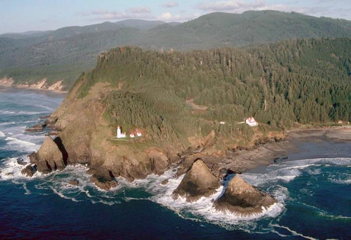
Photograph 8.1. Coastlines vary in their morphology a) The rocky shoreline of a collisional margin at Heceta Head, Oregon. The lighthouse sits on an uplifted marine terrace. Photograph by M. Miller. GEOMORPH0000001287.

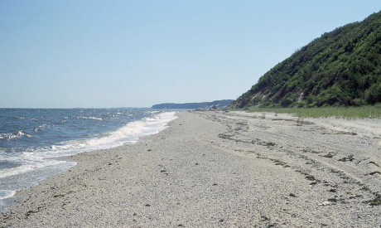

b) Sandy beach along a trailing-edge margin in eastern North America, Wildwood State Park, New York. The cliffs are part of a massive terminal moraine. Photograph by D. Thompson. GEOMORPH0000002511
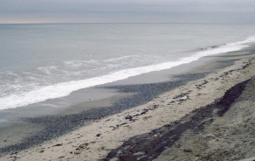
Photograph 8.2 There are various types of breakers. (a) Spilling breakers move gently ashore at Charleston Beach, Rhode Island. Photo by D. Thompson. GEOMORPH0000002519
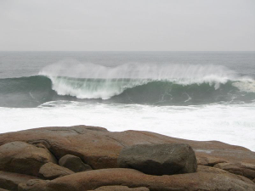
(b) plunging breakers, Plunging breaker, Cape Ann, Massachusetts. Photograph by D. Thompson, GEOMORPH0000002528
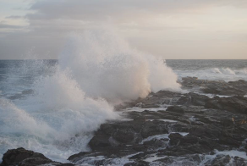
(c) Surging breakers wash over modern or perhaps mid-Holocene marine platform at Cape St Francis, southern Africa. Photo by P. Bierman. GEOMORPH0000001087

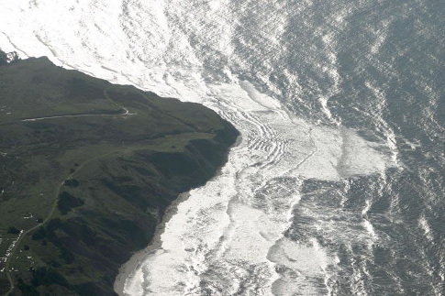
Photograph 8.3 Wave refraction around headland, northern California. Photo by M. Miller. GEOMORPH0000001286
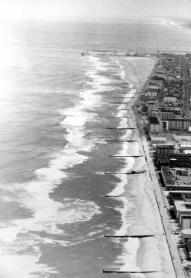
Photograph 8.4. Various types of hard stabilization are used in the coastal environment. All affect the transport of sediment by waves and longshore drift. (a) Groins at Fenwick Island, Maryland disrupt longshore drift. Can you determine which way the sand is moving? Photo by R. Dolan. GEOMORPH000000057

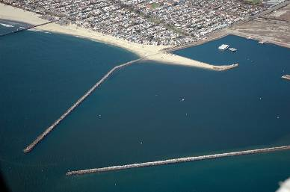
(b) Pair of Jetties at Seal Beach in Anaheim Bay. are used to protect the harbor mouth from sediment moving along the shore. Photo by B. Perry. GEOMORPH0000003281

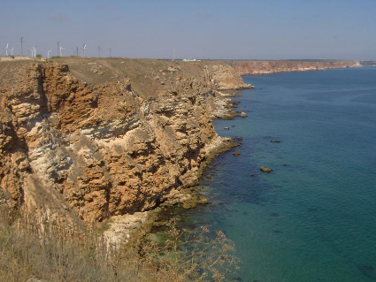
Photograph 8.5 Rocky coasts have diagnostic landforms. (a) Limestone sea cliff on the north Bulgarian Black Sea coast at Cape Kaliakra. The coast here is steep with vertical cliffs reaching 70 m down to the sea. Photo by Hristo Stanchev. GEOMORPH0000000627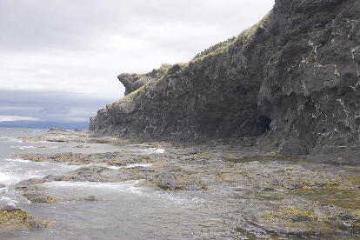
Photograph 8.6 Wave-cut notch and platform at Gros Morne National Park, Newfoundland. Photo by D. Thompson. GEOMORPH0000002609.

NEED PHOTO
Photograph 8.7 Sea Stacks....

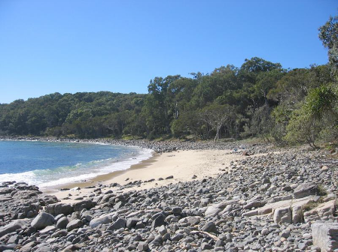

Photograph 8.8 Pocket sandy beach between rocky outcrops in Noosa, northeastern Australia. Photo by P. Bierman. GEOMORPH0000000229.

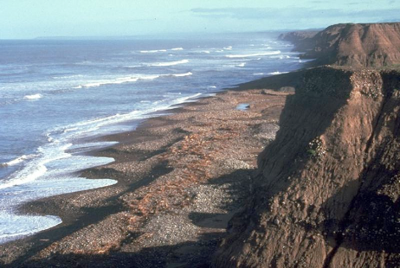
Photograph 8.9 Beach cusps, on gravel beach with steep backing slope. Baja, Mexico. Photo by M. Miller, GEOMORPH0000001353

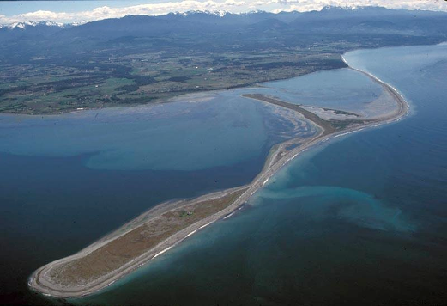
Photograph 8.10 Dungeness Spit, Puget Sound, Washington with the Olympic Mountains in the distance. Photo by M. Miller, GEOMORPH0000001355
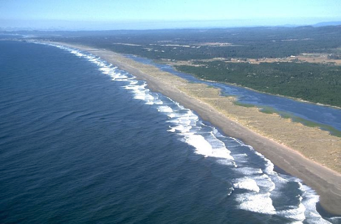
Photograph 8.11 Barrier Island with oblique incoming waves causing longshore drift along the beach. Photo by M. Miller. GEOMORPH0000001358.
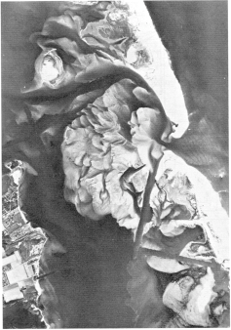
Photograph 8.12 Large tidal delta on the lagoon side of a tidal inlet through a barrier island, formed by a hurricane in September 1947. The very small ebb tidal delta is barely visible. Photo by M. Nichols. GEOMORPH0000003282. [BAD PHOTO CLUB; GET BETTER FLOOD TIDE DELTA WITH DELTA AT INLET]

NEED PHOTO
Photograph 8.13 Lagoon...

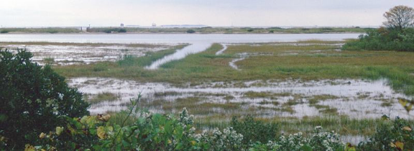
Photograph 8.14 A) View over a salt marsh/tidal flat complex and the adjacent lagoon protected from wave action by a small barrier beach. Bluff Point State Park, Connecticut. Photo by D. Thompson. GEOMORPH0000002495. [BAD PHOTO CLUB; USE A BETTER TIDAL FLAT WITH MEANDERING CHANNELS]

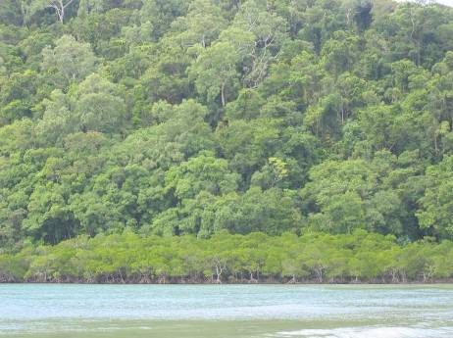
Photograph 8.14 B( Mangroves line beach at base of steep slope in Queensland, Australia. near Cape Tribulation. Photo by P. Bierman. GEOMORPH0000003284.

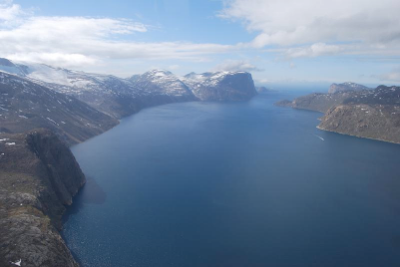
Photograph 8.15 Fiord near Upernavik, central western Greenland, with steep walls tumbling away from low-relief highlands. Cosmogenic exposure dating by Corbett indicates that ice last occupied the fiord about 10,000 years ago. GEOMORPH0000003287
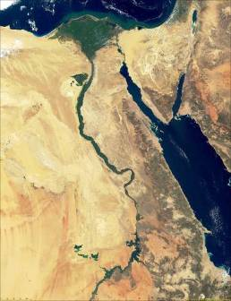
Photograph 8.16. The Nile Delta, bright green from vegetation, shows clearly in this remote sensed image. The Sinai Peninsula and Red Sea are on the right. Photo by NASA. GEOMORPH0000003285.

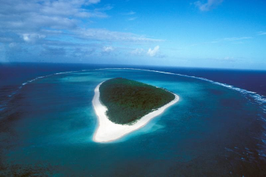
Photograph 8.17 Fringing reef surrounds coral cay (island) and shelters the lagoon from wave energy on the southern Great Barrier Reef, Australia near Heron Island. GEOMORPH0000000037.
Figures Captions
- The geomorphology of active or collisional margins is very different than that of passive or trailing-edge margins.
- Sediment moves onto and away from coasts through a variety of different pathways.
- Tides are an important driver of coastal geomorphic processes. Tidal range changes cyclically.
- Waves are described in terms of wavelength and amplitude.
- Waves behave differently in shallow and deep water. In shallow water waves break and there is sediment transport asymmetry.
- Longshore drift moves large amounts of sediment along beaches due to the fundamental asymmetry of sediment transport by wind-driven waves and gravity.
- Rocky shorelines and shorelines composed of unconsolidated materials have very different characteristic landforms. Rocky shorelines are dominated by bedrock and as a whole are resistant to erosion, changing slowly over time. Unconsolidated shorelines can change rapidly.
- Unconsolidated beaches change their cross-sectional shape with the seasons as sediment moves on shore into berms and then offshore into bars.
- Estuaries vary greatly in their morphology and origin.
- Deltas, formed as rivers deposit sediment into standing water, have a predictable internal architecture.
- The shape of deltas depends strongly on the coastal and fluvial processes, specifically mass fluxes as well as wave and tidal energy, that affect sediment deliver and redistribution.
- Atolls evolve if reef building organisms can produce reef material at a rate equal to the rate of volcanic island erosion and subsidence.
- Submarine canyons dissect the continental shelf and slope and deliver large amounts of terrestrial sediment to the deep ocean.

