Chapter 12. Tectonic Geomorphology

Introduction
Tectonic Drivers
Base Level
Uplift
Density and Thermal Contrasts
Tectonic Settings
Orogens
Rifts
Continental Interiors
Tectonic and Structural Landforms
Transverse Landforms
Compressional Landforms
Extensional Landforms
Structural Landforms
Landscape Adjustment to Tectonics
Coastal Uplift and Subsidence
Hillslopes
Rivers and Streams
Erosional Feedbacks
Applications
Summary
Introduction
Tectonic processes govern the dynamic nature of Earth’s crust and shape the global distribution of continents, ocean basins, and landforms. Setting the template on which climate and erosion interact, tectonics elevates rocks above sea level where weathering prepares the ground for wind, rain, and rivers to erode and sculpt landscapes. It is no coincidence that many of our planet’s major surface features coincide with the boundaries of tectonic plates, where uplift, deformation, and erosion are focused. Tectonically active regions give rise to topography with spectacular vertical relief; tectonically quiescent areas often host broad lowlands with older, less steep highlands. The imprint of tectonics on geomorphology is apparent not only in the size, extent, and location of mountain ranges, but in the localized steepness of river profiles, the character of mountain slopes, and in the form of river networks that flow along regional joint patterns or are offset across faults. Tectonics sets the stage for, and sometimes directs, the work of erosion.
Tectonics influences geomorphology through both active and passive controls. Active tectonic controls involve landscape response to ongoing deformation of the surface, such as the response of a river profile to fault offset and regional uplift. Passive tectonic controls (commonly referred to as structural controls) are those that influence landforms and landscape dynamics indirectly through the variable erosional resistance of different rocks and the effects of geologic structure. In tectonically active regions, geologic structure and lithology often have only minor geomorphic expression during active mountain building as hillslopes driven to threshold slopes mask underlying geologic structures — if everything has about the same slope, structure is difficult to infer from hillslope morphology. But once active tectonic forcing ends, lithology and structure often become dominant controls on landforms. Extremely high rates of erosion in tectonically active areas, such as the Himalaya, can influence the growth and development of geologic structures by focusing both exhumation and isostatic rebound. This chapter explores the role of plate motion (tectonics), heat, and density contrasts in uplifting rock and considers the landforms that result from, and are indicative of crustal deformation and structural controls on landscape evolution.

Tectonic Drivers
Erosion is relentless in striving to decrease the potential energy of landscapes and reduce them to sea level. Maintaining topography over geologic time requires that tectonic processes lift rocks above sea level so as to counteract the loss of mass by erosion. Landscapes continually erode and, given time, eventually come to reflect the balance between the forces driving uplift and the erosional potential arising from the steepness of slopes and rivers draining them. Although surface uplift is dominantly the result of the movement of tectonic plates, crustal buoyancy due to thermal and density contrasts can also promote the elevation of certain areas above neighboring regions. The isostatic response of landscapes to erosion raises fresh rock to replace eroded material even as the average land surface lowers.
Each of these primary mechanisms driving tectonic geomorphology — tectonics, heat, density contrasts, and isostatic response — results in different amounts and styles of uplift. The common element among these tectonic drivers is that rock uplift provides the fodder for erosional processes acting to sculpt the land. In general, the relatively small areas of spectacular mountainous topography that naturally fascinate many people — and most geomorphologists — occur in zones of collisional tectonics along continental margins, extensional rift zones, and in areas that were formerly in such tectonic settings.
The motion of tectonic plates provides the primary energy for elevating rock masses above sea level. Spreading centers along mid-ocean ridges and continental rifts drive plates apart, creating new crust far from where plates collide, crumple, and deform to make mountains. Where plates collide, denser oceanic crust is pushed down and dives beneath lighter continental crust. This creates a subduction zone along which oceanic sediments can be scraped off the downgoing slab to form a sedimentary wedge in front of a plate margin-parallel range of active volcanoes. The Olympic Mountains in western North America are an example of such a range rising seaward of the volcanic arc of the Cascade Mountains.
Volcanic arcs like the Cascades, or the Andes in South America, lie above the point where subducted material descends deep enough (about 100 km) to melt and rise back to the surface in molten form. This gives rise to strikingly linear chains of volcanic islands parallel to the subduction zone and above the subducting plate. The horizontal distance from the subduction trench to the arc of volcanoes varies between many 10s and a few 100s of kilometers and depends on the angle at which the slab subducts; steep subduction reduces the distance because the slab quickly reaches a depth where partial melting and magma generation occur (Photo 12.1).
When two plates of continental crust collide, neither can sink below the other. Instead, they crumple together in a collision that creates high mountains — like the Himalaya — through crustal thickening that builds up the root that supports the range (Photo 12.2).
Where two plates diverge, they create a spreading center associated with crustal thinning and mantle upwelling that can thermally and dynamically maintain rift-flanks higher than surrounding areas. Most spreading centers form mid-ocean ridges, but those that extend into continents form rift valley systems, such as the great eastern African rift system (Photo 12.3)
Within each of these settings, tectonics influences geomorphology across a wide range of spatial scales, ranging from the regional physiography to local fault interactions that can raise some areas and cause others to subside - individual landforms that can be used to map fault traces. At each of these scales, an understanding of tectonic geomorphology can be achieved from landform analysis and an understanding of the underlying geomorphic processes.

Base Level
The concept of base level refers to an idealized surface below which a landscape cannot erode. In the absence of uplift, base level defines the elevation to which erosional processes would reduce a landscape — given time and the energy to do so. In practice, this may be either sea level, the ultimate base level, or a local base level such as lakes, glacial cirques, landslides or lava dams, and structural depressions that form closed basins with no outlet for surface drainage. The signature of changes in base level can be read in landforms such as terraces, canyons, steep knickzones or anomalously flat zones along a river, and in places where unusual river alignments suggest past river capture events. Tectonics can raise or lower a landscape relative to its base level through subsidence or uplift.

Uplift
There are several distinct types of uplift: surface uplift, uplift of rocks, and exhumation — the uplift of rocks relative to the ground surface (Figure 12-1). It is important to avoid potential confusion among these definitions of very similar terms because isostatic compensation results in a major difference between erosion rates, rock uplift rates relative to the land surface, and rates of land surface elevation change. Whereas rock uplift refers to changes in a rock’s vertical position relative to the ground surface (i.e., how deep below ground a rock lies), uplift of the land surface, or surface uplift, refers to the elevation of the ground surface relative to sea level. Although the uplift of rocks is also tied to the same datum (sea level), rock uplift equals surface uplift only if no erosion occurs. In general, surface uplift will equal rock uplift minus erosion, accounting for isostatic compensation (the amount of additional rock uplift triggered in response to erosional unloading). Exhumation of rock describes bringing subsurface rock closer to the ground surface by stripping off the overlying material. Surface uplift, uplift of rock, and the exhumation of rock are all inter-related, but refer to different reference frames.
Unless countered by erosion, tectonically-driven rock uplift will cause net surface uplift. In contrast, the uplift of rock by isostatic compensation occurs when rock is removed by erosion; the net result is surface lowering. Interestingly, this means that the elevation of mountain peaks can rise in response to the excavation of valleys if mass is preferentially removed from valley bottoms because the wavelength of isostatic response typically exceeds the width of valleys. Consequently, in areas with low crustal rigidity (strength) up to a quarter of a mountain’s height can result from the incision of nearby valleys.
Once tectonic uplift ceases, the isostatic response to erosion becomes the dominant form of rock uplift. In any case, erosion itself plays a prominent role in rock uplift. The isostatic response to erosion exhumes rock, bringing deeper rock closer to the ground surface in response to removal of overlying mass from the surface. For each meter of rock stripped off the landscape, isostatic response lifts the underlying rock back up by 80-90 cm due to the density contrast between the less-dense eroded crust (ρ = 2.7 g/cm³) and the more-dense underlying mantle (ρ = 3.3 g/cm³) In tandem with the development of a thick crustal root under active orogens, isostasy means that erosion must remove an amount of rock equivalent to many times the total relief before elevation loss can subdue high mountains once tectonic forcing ceases. Consequently, it can take a long time to erase a mountain range.
The rocks composing Earth's crust have a degree of rigidity that allows the crust to distribute the load of, and partially support topographic loads (Figure 12-2). Flexural rigidity of the crust also means that, in contrast to how erosion occurs as a point process, isostastic rebound is distributed across a wider area. Due to mass redistribution by erosion and deposition can indirectly cause far-field uplift or subsidence due to crustal flexure, the bending of crustal plates from the local addition or removal of a load.

Density and Thermal Contrasts
Density inversions occur where low-density materials underlie higher density materials, creating gravitational instabilities through which buoyancy drives uplift and structural deformation. When a body of salt, such as a deposit of marine evaporites, is buried beneath denser overburden, the salt may rise up through the overlying material to form diapirs, bulbous intrusions that often take odd shapes and can form salt domes where they displace and deform overlying strata. Where rising salt bodies reach the surface they can flow out over the ground as salt glaciers (Photo 12-4), which flow much like conventional glaciers — only much slower. Salt glaciers typically flow at rates on the order of meters per year. Although they are rare on Earth, being concentrated in extremely arid regions such as the Zagros Mountains in Iran, salt glaciers appear to be more common on Mars (although there they might be made of sulfates and other salts rather than halite, sodium chloride). In addition, layers of salts interstratified with other types of rock provide zones of weakness along which substantial deformation may become concentrated.
Density contrasts are also central to igneous processes that lead to volcanoes and volcanic landforms. When crust heats enough to melt it becomes less dense — and therefore gravitationally unstable relative to overlying rock. Molten rock rises if afforded the opportunity through cracking of overlying crust or if the overburden in insufficient to hold the magma at depth. Thermal expansion from volcanic heating or intrusion of molten rock can also result in local or regional uplift, such as when rift zones become elevated due to upwelling of hot rock. Conversely, the elevation of deep sea ridges decreases away from the spreading center at the ridge crest as the newly extruded crust cools upon moving laterally away from the rift (as discussed in chapter 8). In general, thermal contrasts can elevate topography wherever heating from subsurface sources produces lower-density, more buoyant crust.

Tectonic Settings
Tectonic setting is the primary control on the global pattern of regional physiography. Regional tectonic settings of different types of active continental margins, passive margins, and continental interiors strongly influence landforms through styles of tectonic deformation and uplift, differences in dominant lithologies, and the degree of fracturing (which affects erosion resistance). Different types of topography characterize plate margins involving different types of crust (oceanic or continental). However, as tectonic plates generally consist of both oceanic and continental crust, it is most useful to consider separately the dominant controls on the topography of compressional orogens, extensional rift zones, and continental interiors.

Compressional Orogens
Mountain chains form along compressional plate boundaries where tectonic convergence leads to thickening of the crust that, in turn, elevates mountains to a height set by the degree isostatic adjustment. Tectonically active mountain ranges are generally arrayed as linear belts of intensely folded rock where crustal plates converge along subduction zones, such as those on the western margins of North and South America, and at continental collision zones, such as the Himalaya. Mountains of active compressional orogens generally consist of deformed sedimentary rock intruded to varying degrees by igneous rock. Compressional orogens typically have steep slopes, high rates of uplift, and frequent landsliding that delivers high sediment loads to energetic rivers capable of transporting all of that sediment. In active compressional orogens, greatly incised rivers flow through deep, narrow gorges.
Compressional orogens include continental collisions and continental and oceanic volcanic arcs. When two plate margins made of continental crust converge, neither can subduct (because both are of similar density). Consequently, material piles up and the crust thickens, leading to dramatic high-standing mountain ranges like the Himalaya. In contrast, volcanic arcs form along subduction zones where oceanic crust is thrust beneath either continental or oceanic crust. Each of these different types of convergent orogen has different topographic characteristics.
Continental collisions lack significant volcanic activity and have a zone of thrust faulting that typically separates the upland drainage system of bedrock channels from the alluvial channels draining the foreland sedimentary basin (Figure 12-3A). Longitudinal drainage paralleling the strike of a mountain system can develop along zones of faulting, and short, steep channels typically drain the mountain front. Large rivers that cross major mountain ranges (like the Indus and Tsangpo/Brahmaputra which flow from the Tibetan Plateau to cross the Himalaya) are generally thought to represent antecedent channels older than the mountains, channels that were able to maintain their course across the rising range.
Volcanic arcs may be either continental, in which an ocean plate subducts beneath continental crust (Figure 12-3B), or an island arc, in which oceanic crust subducts beneath another plate of oceanic crust (Figure 12-3C). In either case, a wedge of sedimentary rock scraped off of the downgoing, subducting plate rises seaward of the mountains of the volcanic arc that parallels and is fed by the subduction zone. The Olympic Mountains in northwestern North America provide an example of a sedimentary wedge associated with a continental arc, whereas the island of Taiwan represents a sedimentary wedge formed in an oceanic setting (and lacking a volcanic arc due to the geometry of subduction and plate convergence). In general, thick wedges of deformed, highly erodible, fractured sedimentary rock characterize the margins of compressional orogens. In contrast, the spines of volcanic arcs consist of a plate-margin parallel chain of volcanic islands or stratovolcanoes atop massive lava flows (for island arcs) or more erodible andesitic/rhyolitic extrusive rocks (for continental arcs). Deeply exhumed mountain ranges, such as the British Columbia Coast Range or the Sierra Nevada, consist of relatively massive undeformed intrusive igneous rocks (like granite) that represent the exposed roots of ancient volcanic arcs. The Sierra Nevada, for example, are the eroded roots of an ancient continental volcanic arc (like the modern Cascades) that was progressively shut off from its magma source as movement along the San Andreas Fault progressively closed off subduction along the length of the modern range, beginning about 20 million years ago.

Rifts
Mid-ocean ridges constitute most of the world’s extensional rift zones, but where crustal divergence extends onto land it forms dramatic rift valley systems like that of the Rio Grande River in New Mexico and Texas (Figure 12-4). Areas of active continental breakup, rift zones are places where continents are ripped apart. They range in scale from individual valleys like the Dead Sea rift of the Jordan Valley to the extended pull-apart structure of the Basin and Range province of western North America. Ancient, no longer active, rifted continental margins initiated the world’s great escarpments (discussed further in chapter 14) and the East African Rift system, the cradle of human evolution, is still in the early stages of creating a new ocean basin in the heart of Africa.
Rift zones host active volcanism and consist of relatively unfractured basaltic volcanic rocks. The central axial valley generally is part of a system of interconnected grabens atop a great ridge thermally buoyed by a rising mantle plume. Typically, several strands of rift valleys together define a rift system. Large normal fault scarps define the steep inner shoulder of rift systems leading down into closed, internally drained depressions that form deep sedimentary basins and elongated lakes that parallel the rift axis (Photo 12.5). Rockslides typically contribute to high erosion rates on the steeper inboard margin of a rift zone. In contrast, the outboard sides of rift zones typically have gentle slopes and thus few landslides, as well as rivers and streams characterized by a relatively low sediment supply. The topography within rift zones can be broken up into extensive blocks of horsts and grabens separated by substantial escarpments — as in the East African rift zone.
Regional drainage typically flows away from the rifted margin due to crustal flexure and thermal upwarping along the rift zone. Such warping can lead to drainage reversals along an actively developing rift system, with smaller channels more likely to be diverted due to their lower stream power and limited ability to incise bedrock. Drainage development in rift valley systems is dominated by the development of axial drainage along the rift and back-tilted drainage flowing away from the rift escarpment. Shorter, steeper channels drain into the rift, which can host lakes (such as Lake Tanganyika in East Africa) or longitudinal rivers (such as the Rio Grande rift in New Mexico). The major rivers of Africa and South America (with the exception of the Nile) flow toward the passive (trailing-edge) margin on the Atlantic. Many rivers of southern Africa flow over great knickzones along the middle of their courses. The initiation of these knickzones may date from rift margin uplift in response to the breakup of the supercontinent of Pangaea about 200 million years ago.

Continental Interiors
The interiors of continents tend to be tectonically quiescent. Nonetheless, continental interiors may have substantial topography because the combination of isostasy and thickening of continental crust ensures that long-dead mountain ranges have a substantial keel and thus will last for far longer than it took to form them. In general, continental interiors tend to have both low slopes and low overall relief, and can have substantial development of internal drainage where rivers end in closed depressions. Australia is a superb example; 20% of the continent is internally drained. Erosion rates in continental interiors tend to be far slower than in tectonically active settings. Continental interiors in humid, tropical regions tend to develop thick weathering profiles, whereas those in arid regions generally have bare rock slopes. In either case, diffusive processes dominate hillslope transport as there typically is only limited, localized landsliding. Mass movement is limited by the predominance of gentle slopes. Weathering processes generally influence landforms more than physical erosion processes in such environments, and high-standing rock isolated outcrops, known as inselbergs, tend to be best developed in continental interiors (Photo 12.6). In general, ancient, no-longer-active orogens display significant structural control on landforms. For example, the topographic expression of geologic structure is readily apparent in the Appalachians Mountains of eastern North American where resistant units (sandstone and quartzite) form ridge tops and weaker units (shale and limestone) form low-gradient valley bottoms (Photo 12.7).
The vast interiors of continents primarily consist of relatively flat areas known as cratons — tectonically stable regions of relatively low relief, typically rising no more than a few hundred meters above sea level. Cratons are ancient, low-elevation and low-relief continental surfaces that characterize regions of prolonged tectonic stability. In contrast, plateaus are tectonically constructed landforms that are high-elevation, low-relief surfaces formed when continental crust thickens enough to become limited by crustal strength. When continental crust reaches a height of about 4 to 5 km — the height of Asia’s Tibetan Plateau and South America’s Altiplano — geothermal heating weakens the lower crust and makes it susceptible to lateral deformation upon further thickening. This effectively imposes a limit to the mean height of topography dictated by the strength of the crust, as further crustal thickening leads to lateral flow that limits the plateau elevation as lower crustal material oozes sideways. Once a plateau reaches this critical height, further or continued tectonic convergence leads to widening of the plateau, and given enough time development of a broad feature such as the Tibetan Plateau.

Tectonic and Structural Landforms
Tectonic setting and structural geology influence landforms through the direct action of faulting and density contrasts and the indirect influences of spatial variability in erodibility generated by folding, faulting, and juxtaposition of rocks with variable erosion resistance. The topographic influences of tectonics and structural geology depend on the rate, type, and geometry of crustal deformation, as well as differential erosion of rocks involved in the deformation.

Faulting
Faults are discontinuities in Earth's crust across which rocks that did not form adjacent to one another are now juxtaposed. Faults record crustal movement. The topographic expression of faults may result from either offset of rocks across the fault or may be due to fault-influenced patterns of differential erosion. The types of landforms that typically develop in association with fault systems are different along transverse (strike-slip) faults with lateral offset, thrust faults with compressional offset, and normal faults with extensional offset. Fault scarps are steep linear slopes that reflect the direct topographic expression of fault offset (Photo 12-8). Offset across fault scarps is typically several meters per event but can be as great as 5 to 10 m for a single event. The height of a fault scarp often reflects multiple episodes of offset. Although recently exposed fault scarps can be undissected, planar surfaces, scarps become increasingly dissected over time due to erosion of the up-thrown side of the fault. In addition, differential erosion of rocks with contrasting erodibility can accentuate the topographic relief resulting from offset across a fault scarp (Photo 12-9). The topographic expression across a fault can reflect either the sense of offset or the relative erosion resistance of the rocks exposed on either side of the fault.

Transverse Landforms
Strike-slip faults dip steeply and separate crustal blocks or plates sliding laterally past each other, such as along the 1000-km-long San Andreas Fault, which is gradually moving Los Angeles north toward San Francisco. Strike-slip faults are associated with distinctive landforms that often can be used to map multiple fault traces that distribute shear across plate margins in zones tens to a hundred kilometers wide (Figure 12-5). For example, streams that cross strike-slip faults may be offset across the fault, resulting in distinctive right-angle steps and bends that can be used to map the fault course and determine offset directions. Trenching and dating truncated or offset alluvial deposits along such offset streams can reveal the magnitude and history of movement across a fault. Fault offset may even behead streams, separating channels from their source. Distinctive shutter ridges form where lateral fault offset moves a ridge in front of and deflects the course of a stream. Similarly, sag ponds develop where drainage courses are impounded or small depressions form along the trace of strike-slip faults (Photo 12.10). Springs preferentially occur along fault traces due to interception and blockage of subsurface water flow across the fault and/or enhanced discharge through a permeable zone of crushed rock along the fault.
Offset across strike-slip faults can include compressional or extensional components. The geometry of strike-slip fault systems can impose local uplift or subsidence where compression or extension occurs as material moves through bends (Figure 12-6). This results in the development of compressional pop-up structures and pull-apart basins. The Santa Cruz Mountains south of San Francisco, California, are an example of a mountain block uplifted due to compression through a restraining bend where lateral compression of crust squeezes up the mountains as material moves through a bend along the San Andreas Fault. Conversely, San Francisco Bay lies in a subsiding area associated with a releasing bend along the same fault system.

Compressional Landforms
Thrust faulting is the dominant form of tectonic displacement in compressional orogens, but typically has little direct topographic expression. Compressional or thrust faults that place older rocks over younger rocks (Photo 12-11) can extend over hundreds to thousands of kilometers, but typically do not produce distinct topographic scarps. Many thrust faults either terminate in blind thrusts before reaching the surface or splay out into multiple fault traces near the surface. In some places, however, rates of active surface deformation associated with folding may exceed erosion rates and result in the formation of an anticlinal ridge, such as the Yakima Folds in eastern Washington and the Ventura anticline in southern California (Figure 12-7). There, dating sets of river terraces bowed upward and deformed across the rising fold (anticline) allow calculation of the rate of surface uplift and reveal the broad pattern of uplift centered on the crest or hinge of the anticline.

Extensional Landforms
Extensional or normal faults often exhibit distinct fault scarps marking their course along a range front (Figure 12-8). Where rivers or streams incise v-shaped valleys across such a fault scarp the intervening slopes are characterized by distinctive triangular facets (Photo 12-12) that can appear as if cleaved at a stroke from solid rock. Along many extensional range fronts, active faulting visibly offsets alluvial fans and glacial moraines developed at the topographic break-in-slope that separates bedrock uplands from alluvial lowlands (Photo 12-13). Sets of normal faults can interact to form high-standing horsts or down-dropped grabens. Grabens typically form broad, flat-floored valleys that may create closed depressions, such as Death Valley, an internally-drained depression 116 m below sea level. Normal fault scarps typically form steep, linear sections of slope that become progressively rounded over time as hillslope processes redistribute material from the scarp to lower on the slope (see chapter 5). Surface ages, patterns of offset, and the stratigraphy in such locations can be used to date episodes and determine frequencies, and therefore rates, of fault offset.
Regional extension can result in distinctive large-scale topography. In particular, the linear north-south trending mountain ranges that collectively define the Basin and Range province of western North America are due to large-scale normal faulting resulting from tectonic extension of the region. Representing the toppled ends of gigantic tilted crustal blocks, before they were pulled apart these fault-block mountains formed an extensive high elevation plateau (Figure 12-9).

Structural Landforms
It is hard to discern a topographic signature of geologic structure in many tectonically active regions like the Himalaya and Taiwan where slopes maintain relatively uniform steepness (threshold slopes) regardless of the underlying structure and patterns of rock uplift (Figure 12-10). Once tectonically driven rock uplift declines or ceases, structure and lithology exert a more pronounced influence on topography. Differences in erodibility come to dominate erosion rates and landforms, and different lithologies or structures can dominate slope form. Although it is hard to map geologic structures directly from the topography in tectonically active areas like the Himalaya and Taiwan, it is relatively straightforward to map geologic structures directly from topography in the tectonically inactive Appalachians where strong differences in bedrock erodibility lead to striking differences in topography (Photo 12.7). Geologic structure can dominate landform development in tectonically inactive landscapes like the Appalachians where the underlying geology strikingly governs ridge and valley patterns (Figure 12-11).
Because folding and deformation of rocks generally occur slowly and deep within Earth’s crust, the topographic expression of folds results from differential erosion of strata with variable erosion resistance. As erosion cuts through the hard, ridge-forming beds it can expose weaker underlying rocks, which can then erode at a faster pace. This can lead to a topographic inversion wherein the crest of the anticline becomes breached, forming a topographic low along the structural high through excavation of an anticlinal valley carved out from the interior of the anticline.
The inclination or dip of underlying beds can greatly influence landform development. Monoclines are where the dip of strata increases locally, but the beds do not turn over, producing a structural and topographic step (Photo 12-14A). In regions with large variations in erosion resistance, steeper slopes tend to form on more erosion-resistant rocks, whereas gentler slopes characterize more erodible rocks. Erosion of gently dipping beds can lead to the development of asymmetric slopes called cuestas that are elongated in the down dip direction (Photo 12-14B). More symmetric slopes where the underlying beds dip approximately 45° are known as hogbacks (Photo 12-14C) that exhibit pronounced dip slopes where the hillslope angle parallels rock bedding. Erosion-resistant beds in flat lying strata in which exposure of hard cap-rock layers can protect underlying beds and lead to the development of mesas, steep-walled, flat-topped plateaus like those in Monument Valley, Utah, or the Gamsburg in Namibia (Photo 12-14D). Mesas are often protected by an erosion-resistant cap rock that retards erosion on the mesa top, leading to steep walled sides.

Landscape Adjustment to Tectonics
The development of topographic slopes in response to relative uplift drives geomorphology more than does absolute elevation. A flat surface at high altitude will erode slowly whereas a steep slope at low elevation will erode relatively quickly. Both base level fall and tectonic uplift can increase topographic relief and steepen both hillslopes and rivers. Uplift of the land surface relative to local or global base level (surface uplift) can trigger an increase in local slope that sweeps up through a river system, driving a wave of incision toward the headwaters of a drainage basin. It is the increased topographic gradient (slope), that actually drives changes in erosional processes.
Tectonic forcing can reorganize drainages and change drainage basin boundaries. For example, continental rifting opens new basins and beheads existing drainages. Tectonic tilting of existing basins can reverse flow or cause one stream to erode headward more rapidly than another, eventually beheading the captured stream and creating a new and expanded drainage network. Such truncated basins are common in tectonically active areas and are often identified by stranded fluvial gravels at high elevation. A good example can be found in the northern Galilee in Israel where basaltic gravel from the Syrian highlands is found on the local limestone bedrock; yet, today there is no fluvial connection between the outcrops and the gravels.
More subtle responses to tectonic forcing are common in drainage basins. Slow tilting changes base levels. Rising base levels lead to aggradation and basin filling whereas falling base levels cause incision and the creation and preservation of terraces. A key difference to note is that the effects of a base level drop eventually extend up through the whole channel system, whereas base level rises primarily affect lower reaches of rivers, drowning deltas and turning coastal valleys into estuaries and bays. Coastal environments, hillslopes, and fluvial systems all respond differently to tectonic forcing.

Coastal Uplift and Subsidence
On tectonically active margins, local structural configuration can make some areas prone to long-term tectonic subsidence. The San Francisco Bay is an example of a landform created through tectonic subsidence of a fault-bounded block caught in an extensional pull-apart zone between two strike-slip faults, resulting in the drowning of a former river valley. Coastal subsidence can also accompany large subduction-related earthquakes along active margins. Drowned forests and marsh deposits covered by layers of tsunami-deposited sand along the coast of Northern California, Oregon, and Washington testify to long periods of slow coastal uplift separated by episodes of rapid subsidence during large earthquakes (Photo 12-15). This can result in periods of marine inundation even on an actively uplifting coast.

Coastal Uplift and Marine Terraces
The coastlines of many tectonically active continental margins consist of rocky coasts where sea cliffs rise from beaches. Wave action can abrade a gently sloping wave-cut platform that slopes (pitched seaward at about 1°) from a wave-cut notch at the base of the sea cliff to below the level of tidal influence. When sea level falls along an actively uplifting coast, the former sea cliff and planed off wave-cut platform continue to rise, which results in the formation and exposure of a marine terrace, a gently sloping surface of low relief that defines the shoreline angle where it meets the former sea cliff. Marine terraces exposed to subaerial erosion gradually become progressively more incised as the abandoned sea cliffs erode and become more subdued, with the shoreline angle declining over time. Over multiple cycles of eustatic sea level rise and fall (due to variations in the amount of glacial ice at the poles), multiple marine terraces can form on actively rising coastlines, with younger terraces closest to sea level and older, increasingly eroded terraces at progressively higher elevations. The series of multiple marine terraces formed by uplifted coral reefs on the coast of New Guinea provides a classic example of landforms resulting from tectonic uplift (Photo 12-16). On this and many other rising, tectonically active coastlines, such as those of Northern California and Japan, individual marine terraces can be correlated with sea level high stands, which allows one to estimate coastal uplift rates back through time from the relative elevations of different marine terraces (Figure 12-12).

Hillslopes
The steepness of hillslopes can respond to changes in tectonic forcing — up to a point. Soil-mantled slopes can only get so steep before landsliding limits further steepening. In low- to moderate-gradient landscapes, slope steepness generally increases with increasing rock uplift such that erosion rates are strongly correlated with slope, steeper slopes leading to more rapid erosion. However, the angle of soil-mantled slopes can only increase to an upper limiting or threshold angle of no more than about 35°, roughly equal to the friction angle of dry granular material, because soils tend to slide off of steeper slopes even when dry and plant roots can only provide so much reinforcement. Once hillslopes steepen to threshold angles, erosion rates will respond to further increases in rock uplift through more frequent landsliding because the hillslopes cannot support further steepening in response to river incision. The contrasting behavior of threshold and sub-threshold slopes means that hillslope angles in gentle, sub-threshold terrain can respond to increased uplift rates or base level fall through steepening, whereas the morphological response of landscapes with steep, threshold slopes would be expected to be most pronounced in stream profiles (see below) or to involve stripping of soil to expose bare bedrock slopes and/or proliferation of deep-seated bedrock landsliding.
Slopes steepen where rivers incise into bedrock faster than hillslopes erode. The development of inner gorges, defined by zones of steeper slopes low on valley walls that create a distinct valley-within-a-valley morphology (Photo 12-17), is generally interpreted to represent response to either falling base level or an increase in uplift rate. In this view, as river incision increases, the lower portion of valley walls steepen first, creating a distinct break in slope that defines an inner gorge. However, an alternative hypothesis for the development of inner gorges holds that more frequent landsliding due to greater moisture lower on valley walls leads to steeper slopes and the development of inner gorge morphology without an increase in the pace of river incision. In many formerly glaciated regions, such as the Swiss Alps, narrow V-shaped fluvial gorges are incised into the bottom of broad U-shaped glacial valleys. Such inset valleys may represent incision in response to post-glacial base level fall (or isostatic rebound) or the longer-term interplay of glacial and fluvial incision over multiple cycles of glacier advance and retreat along alpine valley systems.

Rivers and Streams
Rivers and streams developed on rocks of uniform lithology and constant uplift rate typically develop smoothly concave longitudinal profiles, with steeper reaches in the basin headwaters progressively giving way to gentler reaches downstream (see chapter 7). Local departures from this generalized pattern arise from variations in the erodibility of the bedrock riverbed due to differences in lithology, the inherited influences of glacial erosion on profile form, and spatial variations in rock uplift rate. Rivers and streams primarily respond to tectonic forcing through adjustments in slope. Spatial variations in rock uplift along a river profile can lead to reaches steeper, or flatter than expected along a river's longitudinal profile. A plot of the downstream values in the stream gradient index (chapter 6) can identify reaches of anomalous steepness (or flatness), and suggest locations where faults may be influencing channel slopes. Methods for analyzing such deviations include the stream-gradient index and drainage area-slope analyses (see below). In addition, steep sections of a river profile tend to erode faster than gentler reaches, which causes knickpoints to migrate upstream and in extreme cases can lead to one river capturing and diverting all or a portion of another.
The relationship between a drainage basin and its base level can change through tectonic subsidence, uplift of the land or a rise or fall in sea level. Base level changes greatly affect the locus of sedimentation in coastal zones. Rivers respond to a rising base level through deposition in their lower reaches, building a depositional wedge or ramp of sediment that extends progressively upstream (Figure 12-13). Above this depositional zone the channel network remains relatively uninfluenced by the change other than now being graded to a higher base level. In contrast, channels respond to a falling base level by incising in their lower reaches, the resulting steeper channel segment producing a wave of incision that sweeps up through the drainage network as a migrating knickpoint.
On an uplifting coastline flights of strath (bedrock) terraces can rise above the modern river floodplain, recording progressive incision of the river. Such terraces can be correlated by height, just like marine terraces, and often can be traced up through a river network. By dating the age of terraces at different elevations one can determine rock uplift rates. Although they may occur in any lithology, strath terraces appear to be better developed in sedimentary rocks than in harder crystalline rocks. In addition, temporal variations in sediment supply have been argued to play a role in strath terrace formation by influencing the amount of sedimentary cover protecting the underlying bedrock from erosion.

River Channel Morphology
River channel morphology also can serve as a sensitive indicator of tectonic deformation, as channel patterns respond to changes in slope due to differential uplift along their courses. Braided channels tend to incise in response to localized steepening of their longitudinal profile, whereas meandering channels typically first decrease their sinuosity in response to tectonic steepening before then incising. Meandering channels may even braid with enough of a change in slope. However, the effect of vertical fault offset along a river profile depends on the magnitude and sense of offset. Sufficient upward displacement on the downstream side of a fault can impound a lake, whereas upward displacement on the upstream side of the fault will create an oversteepened reach (knickpoint), or waterfall.

Drainage Area-Slope Analyses
A more formal way to assess the adjustment of channel slopes, and therefore river profiles, to tectonic activity comes through positing a balance between rates of rock uplift (U) and river incision (E) to predict the form of steady-state river profiles. Generally, the erosive potential of a river may be expressed as a function of its drainage area (A) and its local slope (S), as a larger and steeper river will have greater power to cut down into rock. Hence, using a constant (K) to characterize bedrock erodibility and the role of climatic factors and basin geometry that contribute to setting how the river’s discharge scales with its drainage area results in an expression of the form
E = K • A^{m} • S^{n} (12-1),
where the scaling exponents m and n are generally considered to have values of 1.0 and 0.5, respectively. For the idealized case of a steady-state river profile eroding everywhere along its length at the rock uplift rate, U = E and thus
U = K • A^{m} • S^{n} (12-2),
which may be rearranged to yield an expression for how channel slopes would be expected to vary as a function of drainage area
S = (U/K) • A^{-(m/n)} (12-3).
Equation 12-4 predicts that the steady-state profile of an incising bedrock river will plot as a straight line on a logarithmic graph, with a slope equal to -m/n and a coefficient directly related to the ratio of the uplift rate to the bedrock erodibility (U/K).
Area-slope plots can be used to identify locations along a bedrock river profile where uplift rates change, as such changes will show up as zones of different slope on such plots (Figure 12-14). Portions of an upland river system with higher rock uplift rate (U) will plot at higher slopes for the same drainage area than will reaches with lower rock uplift rates. Ratios of U/K determined for different reaches of a river system can be used to estimate relative differences in the value of rock uplift rates in different portions of a river system, if, of course, one has accounted for any differences in lithology, discharge, and bedrock erodibility, which may influence the denominator of the ratio. Unlike values of hillslope gradient that become asymptotic to erosion rate, K values appear to increase systematically with erosion rate.

Erosional Feedbacks
Rapid erosion driven by focused river incision can lead to highly localized exhumation and isostatic rebound to produce a feedback through which river incision influences the development of geologic structures. The degree of erosion-tectonic coupling produces a range of effects and erosion of deep valleys can focus exhumation, resulting in preferential rock uplift (through isostatic rebound) focused along major rivers. This can produce a river anticline defined by the crest of a structural fold running parallel to the river, with the greatest uplift centered along the river. The odd situation of a river flowing along the structural high, perched atop the spine of the anticline, characterizes major trans-Himalayan rivers, like the Arun River just east of Mount Everest. The anticlinal structure running along the Arun River has an amplitude of over 10 km, structural relief comparable to the height of Everest. This and similar geologic structures oriented transverse to the trend of the compressional mountain range they drain are the youngest deformational structures in the Himalaya. Their young ages indicate that they developed in response to incision along the course of the river and thus that the river did not simply take advantage of pre-existing structure to establish its course across the rising range. In other words, the focused erosion along the course of an energetic river produced sustained gradients in isostatic response that led to greater exhumation along the course of the river.
In the dramatic cases of where the mighty Indus and Tsangpo rivers — the most powerful and erosive in Asia — slice through deep gorges at either end of the Himalaya, extremely rapid river incision (>10 mm yr⁻¹) has resulted in the development of deeply exhumed geologic structures expressed as a bulls-eye pattern of young, high-grade metamorphic rocks in the region surrounding the deeply incised and rapidly eroding gorge. Similarly, greater rainfall on the windward side of a mountain range can result in differential exhumation that strongly influences structural development on either side of the drainage divide and leads to exposure of more deeply exhumed rocks on the wetter, windward side of the range, such as in the rain-drenched western slope of the southern Alps of New Zealand.

Applications
Tectonic geomorphology has direct applications to understanding seismic hazards and indirect applications to understanding the physiographic history of particular regions. The tools and approaches of tectonic geomorphology are central to understanding why different types of rocks and landforms are often found together in different parts of the world. Mapping the distribution and alignment of fault-related landforms is a standard technique employed to identify fault traces in seismic hazard assessments. In California, building and development is limited and more highly regulated in zones along active faults. Similar techniques are used in site investigations for seismically vulnerable infrastructure, such as nuclear power plants. Tectonic geomorphology is also used to assess the activity of geologic faults along active mountain fronts in both densely populated areas as along California’s San Andreas Fault and in relatively inaccessible regions, such as in parts of the High Himalaya. The physiographic expression of faults and fault zones can be used to evaluate seismic hazards. Mapping the traces of faults allows identifying locations at risk of direct fault offset. In particular, identifying the character and extent of fault zones allows estimating the size and characteristics of anticipatable earthquakes.

Summary
Tectonic geomorphology structures how we read the story of Earth’s dynamic surface to connect regional physical geography to the deep earth processes of geology. Consequently, understanding the role of tectonic processes on geomorphic processes and landforms holds the key to understanding the geomorphology of many regions around the world. The broad patterns of uplift governed by tectonic processes provides the raw material and template upon which erosion works to sculpt landscapes. Structural patterns inherited from ancient tectonic deformation can greatly influence modern landforms through sustained variability in erosion resistance. Tectonics and erosion are complicated through the development of hillslope angles, river profiles, and the dynamics of continental wedges. Spatial patterns of erosional processes, if sustained for long enough, can influence the development of geologic structures. Earth's surface and interior influence each other and it behooves us to understand the dynamic nature of Earth's surface.

Selected References and Further Reading
Ahnert, F., 1970, Functional relationships between denudation, relief, and uplift in large mid-latitude basins, American Journal of Science, v. 268, p. 243-263.
Anderson, R. S., 1990, Evolution of the Northern Santa Cruz Mountains by advection of crust past a San Andreas Fault bend, Science, v. 249, p. 397-401.
Anderson, R. S., and Menking, K. M., 1994, The Quaternary marine terraces of Santa Cruz, California: Evidence for coseismic uplift on two faults, Geological Society of America Bulletin, v. 196, p. 649-664.
Anderson, R. S., Densmore, A. L., and Ellis, M. A., 1999, The generation and degradation of marine terraces, Basin Research, v. 11, p. 7-20.
Andrews, D. J., and Hanks, T. C., 1985, Scarp degraded by linear diffusion: Inverse solution for age, Journal of Geophysical Research, v. 90, p. 10,193-10,208.
Atwater, B. F., 1987, Evidence for great Holocene earthquakes along the outer coast of Washington state, Science, v. 236, p. 942-944.
Baldwin, J. A., Whipple, K. X., and Tucker, G. E., 2003, Implications of the shear-stress river incision model for the timescale of post-orogenic decay of topography, Journal of Geophysical Research, v. 108, doi: 10.1029/2001JB000550.
Bilham, R., and King, G., 1989, The morphology of strike slip faults: Examples from the San Andreas Fault, California, Journal of Geophysical Research, v. 94, p. 10,204-10,226.
Burbank, D. W., and Anderson, R. S., 2001, Tectonic Geomorphology, Blackwell Science, Malden.
Burbank, D. W., Leland, J., Fielding, E., Anderson, R. S., Brozovic, N., Reid, M. R., and Duncan, C., 1996, Bedrock incision, rock uplift, and threshold hillslopes in the northwestern Himalaya, Nature, v. 379, p. 505– 510.
Colman, S. M., and Watson, K., 1983, Age estimated from a diffusion equation model for scarp degradation, Science, v. 221, p. 263-265.
Crosby, B. T., and Whipple, K. X., 2006, Knickpoint initiation and distribution within fluvial networks: 236 waterfalls in the Waipaoa River, North Island, New Zealand, Geomorphology, v. 82, p. 16–38.
Densmore, A. L., Ellis, M. A., and Anderson, R. S., 1998, Landsliding and the evolution of normal-fault-bounded mountains, Journal of Geophysical Research, v. 103, p. 15,203-15,219.
England, P., and Molnar, P., 1990, Surface uplift, uplift of rocks, and exhumation of rocks, Geology, v. 18, p. 1173-1177.
Gardner, T. W., 1983, Experimental study of knickpoint migration and longitudinal profile evolution in cohesive homogeneous material, Geological Society of America Bulletin, v. 94, p. 664-672.
Gilchrist, A. R., and Summerfield, M. A., 1990, Differential denudation and flexural isostasy in formation of rifted-margin upwarps, Nature, v. 346, p. 739-742.
Gilchrist, A. R., Summerfield, M. A., and Cockburn, H. A. P., 1994, Landscape dissection, isostatic uplift, and the morphologic development of orogens, Geology, v. 22, p. 963-966.
Hack, J. T., 1973, Stream-profile analysis and stream-gradient index, Journal of Research of the United States Geological Survey, v. 1, p. 421–429.
Finlayson, D., Montgomery, D. R., and Hallet, B. H., 2002, Spatial coincidence of rapid inferred erosion with young metamorphic massifs in the Himalayas, Geology, v. 30, p. 219-222.
Kirby, E., and Whipple, K., 2001, Quantifying differential rock-uplift rates via stream profile analysis, Geology, v. 29, p. 415–418.
Koons, P. O., 1989, The topographic evolution of collisional mountain belts: A numerical look at the Southern Alps of New Zealand, American Journal of Sciences, v. 289, p. 1041–1069.
Lavé, J., and Avouac, J. P., 2000, Active folding of fluvial terraces across the Siwalik Hills Himalaya of central Nepal, Journal of Geophysical Research, v. 105, p. 5735-5770.
Martel, S. J., Harrison, T. M., and Gillespie, A. R., 1987, Late Quaternary displacement rate on the Owens Valley Fault Zone at Fish Springs, California, Quaternary Research, v. 27, p. 113-129.
Merritts, D., and Bull, W. B., 1989, Interpreting Quaternary uplift rates at the Mendocino triple junction, Northern California, from uplifted marine terraces, Geology, v. 17, p. 1020-1024.
Merritts, D. J., Vincent, K. R., and Wohl, E. E., 1994, Long river profiles, tectonism, and eustasy: A guide to interpreting fluvial terraces, Journal of Geophysical Research, v. 99, p. 14,031-14,050.
Molnar, P., Anderson, R. S., and Anderson, S. P., 2007, Tectonics, fracturing of rock, and erosion, Journal of Geophysical Research, v. 112, F03014, doi:10.1029/ 2005JF000433.
Montgomery, D. R., 1994, Valley incision and the uplift of mountain peaks, Journal of Geophysical Research, v. 99, p. 13,913-13,921.
Montgomery, D. R., and Stolar, D., 2006, Revisiting Himalayan river anticlines, Geomorphology, v. 82. p. 4-15.
Morisawa, M., and Hack, J. T., (editors), 1985, Tectonic Geomorphology, Allen & Unwin, Boston, 390p.
Oberlander, T. M., 1965, The Zagros Streams, Syracuse University Geographical Series No. 1.
Ouimet, W., Whipple, K., and Granger, D., 2009, Beyond threshold hillslopes: Channel adjustment to base-level fall in tectonically active mountain ranges, Geology, v. 37, p. 579-582.
Ollier, C. D., 1981, Tectonics and Landforms, Longman, London and New York.
Pritchard, D, Roberts, G.G., White, N.J., et al., 2009, Uplift histories from river profiles, Geophysical Research Letters, v. 36, Art. No. L24301.
Roe, G. H., Whipple, K. X., and Fletcher, J. K., 2008, Feedbacks among climate, erosion, and tectonics in a critical wedge orogen, American Journal of Science, v. 308, p. 815-842.
Schumm, S. A., Dumont, J. F., and Holbrook, J. M., 2000, Active Tectonics and Alluvial Rivers, Cambridge University Press, Cambridge.
Seeber, L., and Gornitz, V., 1983, River profiles along the Himalayan arc as indicators of active tectonics, Tectonophysics, v. 92, p. 335-367.
Sieh, K. E., and Jahns, R. H., 1984, Holocene activity of the San Andreas fault at Wallace Creek, California, Geological Society of America Bulletin, v. 95, p. 883-896.
Suppe, J., 1985, Principles of Structural Geology, Prentice-Hall, Englewood Cliffs, N. J.
Trudgill, B. D., 2002, Structural controls on drainage development in the Canyonlands grabens of southeast Utah, American Association of Petroleum Geologists Bulletin, v. 86, p. 1095-1112.
Valensise, G., and Ward, S. N., 1991, Long-term uplift of the Santa Cruz coastline in response to repeated earthquakes along the San Andreas fault, Bulletin of the Seismological Society of America, v. 81, p. 1694-1704.
Wager, L. R., 1937, The Arun River drainage pattern and the rise of the Himalaya, Geographical Journal, v. 89, p. 239–250.
Whipple, K. X., 2009, The influence of climate on the tectonic evolution of mountain belts, Nature Geoscience, v. 2, p. 97-104.
Whipple, K. X., and Tucker, G. E., 1999, Dynamics of the stream-power river incision model: Implications for height limits of mountain ranges, landscape response timescales, and research needs, Journal of Geophysical Research, v. 104, p. 17,661-17,674.
Whittaker, A. C., Cowie, P. A., Attal, M., Tucker, G. E., and Roberts, G. P., 2007, Contrasting transient and steady-state rivers crossing active normal faults: New field observations from the Central Apennines, Italy, Basin Research, v. 19, p. 529-556.
Willett, S. D., Orogeny and orography: the effects of erosion on the structure of mountain belts, Journal of Geophysical Research, v. 104, p. 28,957-28,982.
Wobus, C. W., Hodges, K. V., and Whipple, K. X., 2003, Has focused denudation sustained active thrusting at the Himalayan front?, Geology, v. 31, p. 861-864.
Zeitler, P. K., Meltzer, A. S., Koons, P. O., Craw, D., Hallet, B., Chamberlain, C. P., Kidd, W. S. F., Park, S. K., Seeber, L., Bishop, M., and Shroder, J., 2001, Erosion, Himalayan geodynamics, and the geomorphology of metamorphism. GSA Today, v. 11, p. 4-9.

Photos

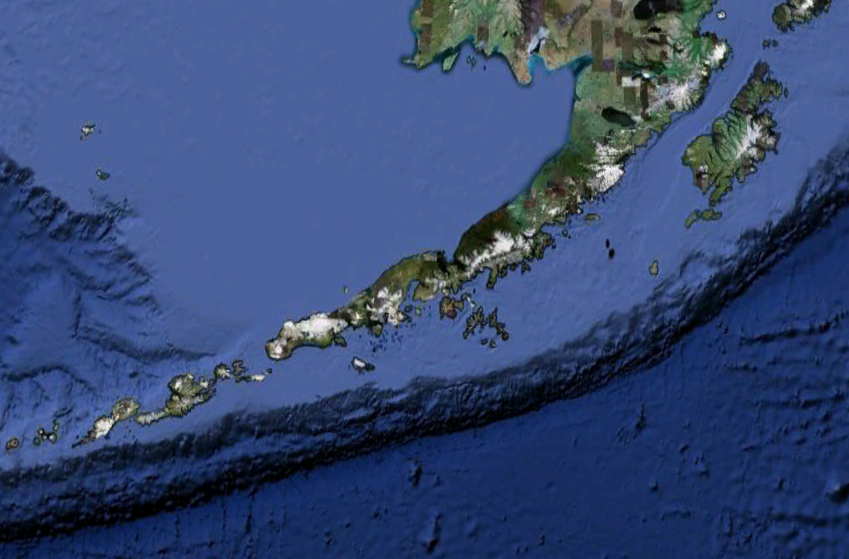
Photo 12.1. Digital elevation model of the Aleutian arc and adjacent trench showing how the arc of subduction-related volcanoes parallels the subduction zone. Note: this is a Google image – need to get higher resolution version and annotate.
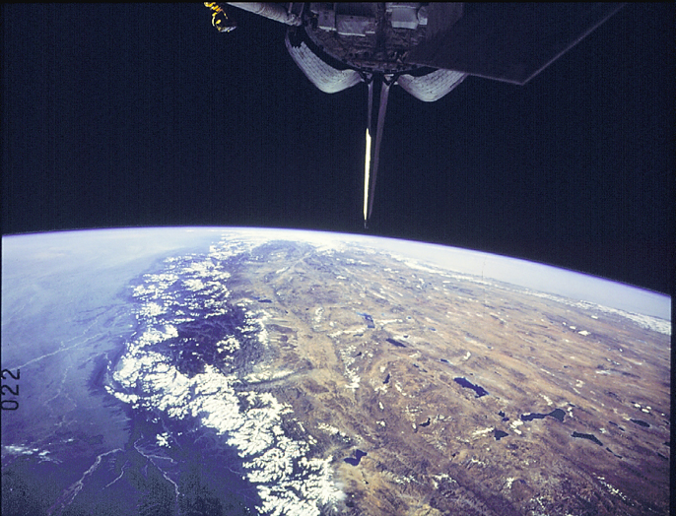
Photo 12.2. View from the space shuttle of the Himalayan front and Tibet. Need original NASA source image.
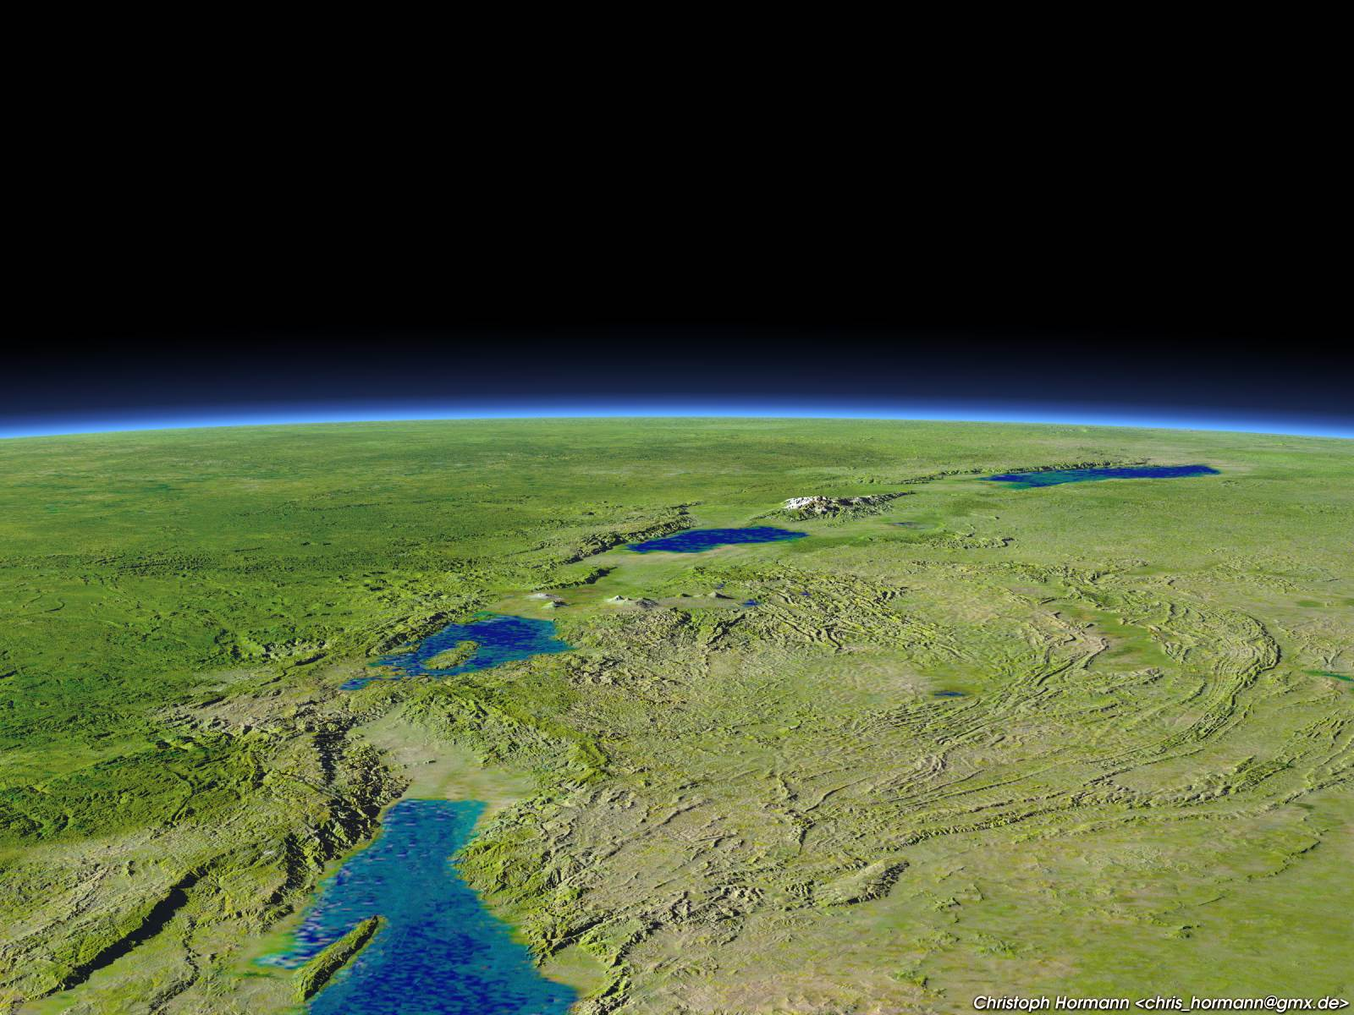
Photo 12.3 Synthetic image based on digital topography of east African Rift Valley clearly shows lakes along the rift axis. Image by Christoph Hormann. http://www.imagico.de/pov/pict/earth_rift.jpg
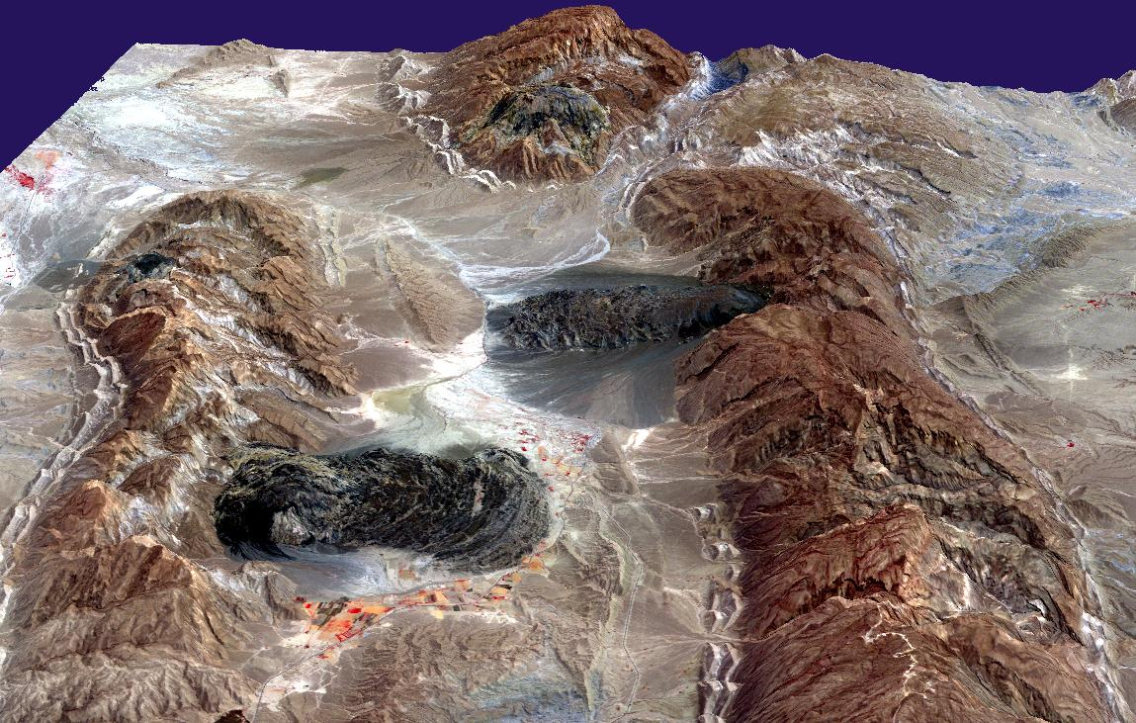
Photo 12.4 Dark colored salt flowing from Zagros Mountains in southern Iran, a zone of collision and uplift. The salt is less dense than the surrounding rock and moves upward as diapiars. When these diapiars reach the surface, the salt flows ductily under gravity-induced stress. http://www.solarviews.com/cap/earth/saltglacier.htm
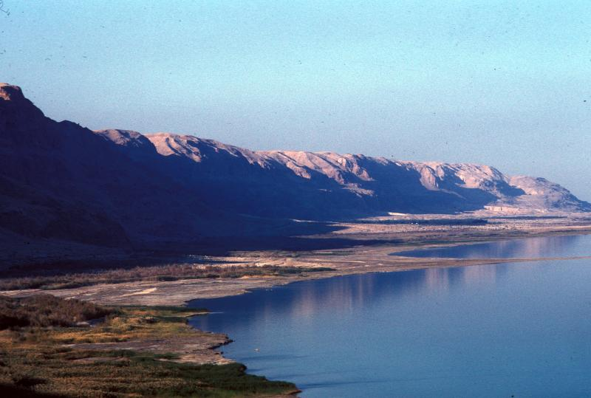
Photo 12.5 The internally drained Dead Sea and the adjacent steep, faulted rift margin or rift shoulder in Israel. This is the inboard, steep side of the rift. GEOMORPH0000000076. Photo by P. Bierman.
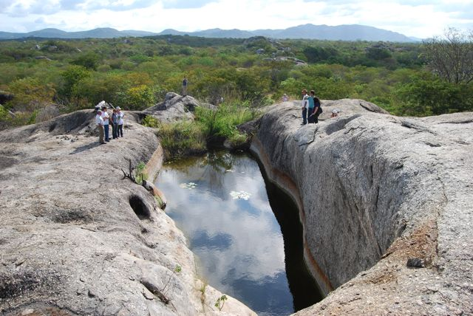
Photo 12.6. View of deep weathering pit on an inselberg filled with water, sediment, and tons of Pleistocene megafauna bones in Pernambuco State, Brazil. Despite being a tectonically quiet continental interior, there is substantial relief in this landscape. GEOMORPH0000006291. Photo by P. Bierman.
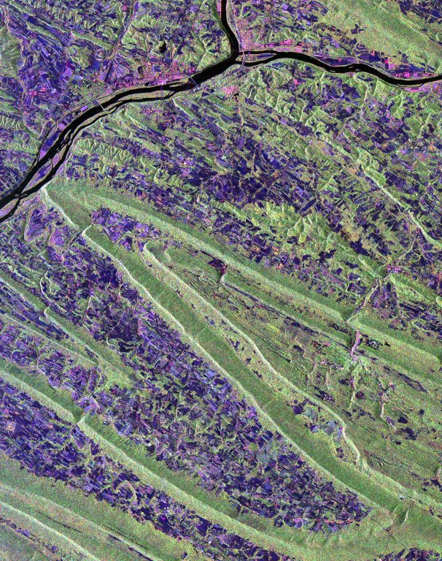
Photo 12.7 There is strong structural and lithologic control of large scale geomorphology in the tectonically inactive Appalachian Mountains of eastern North America. This NASA radar image shows the large plunging folds of the Valley and Ridge physiographic province near Harrisburg, PA. The ridge lines are held up by resistant sandstone and the valleys are dominated by shale and limestone. The view is about 20 miles wide. GEOMORPH0000006292. Image by NASA.

Photo 12.8 Scarps provide surface evidence of faulting scarp Thrust fault scarp in Tibet offsets a river terrace on which the vehicle is parked. Photo by R. Hetzel. GEOMORPH0000006296. B. Normal fault scarp in limestone in the northern Galilee of Israel leads directly to a village. GEOMORPH0000000411. C. Fence offset by the 1906 San Francisco earthquake along the strike-slip San Andreas fault in Marin County, CA. Photo by G.K. Gilbert. GEOMORPH0000003322
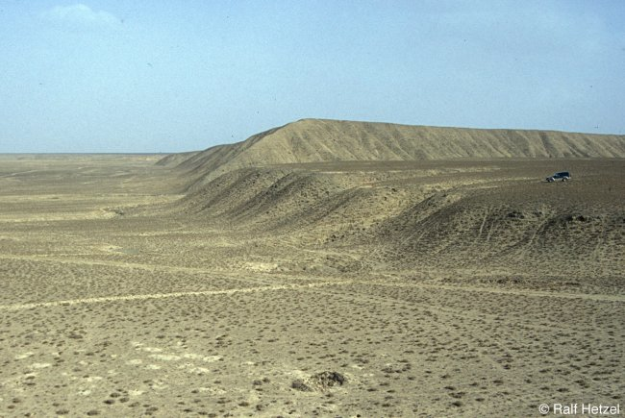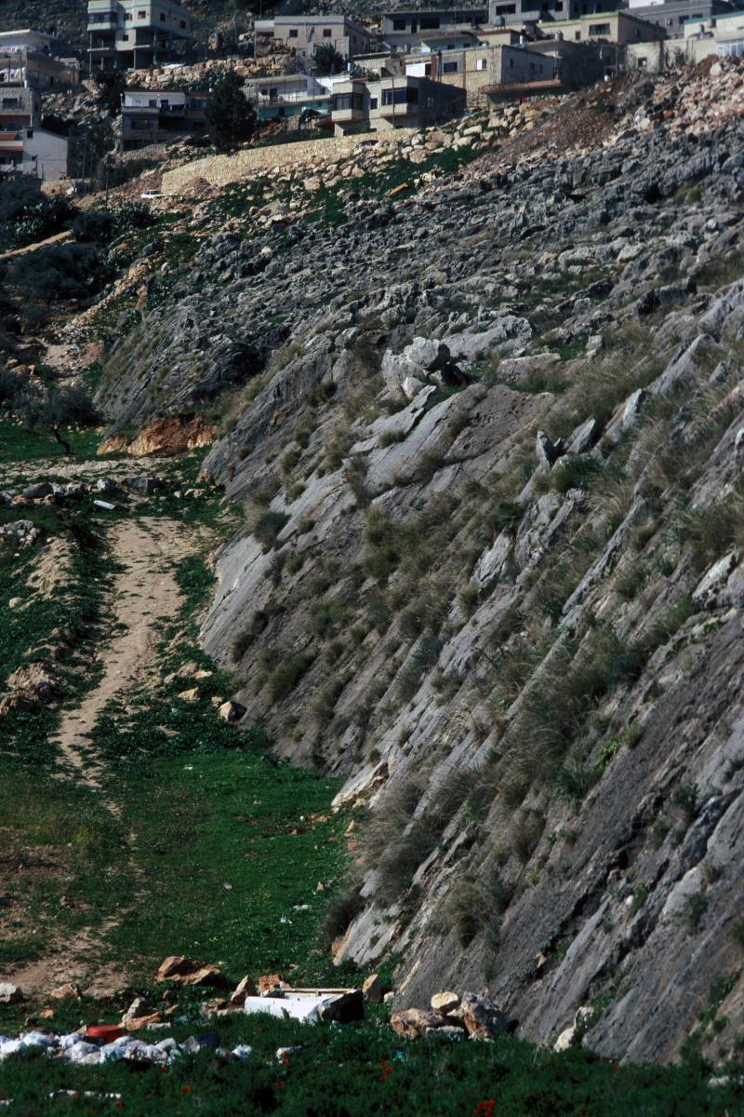
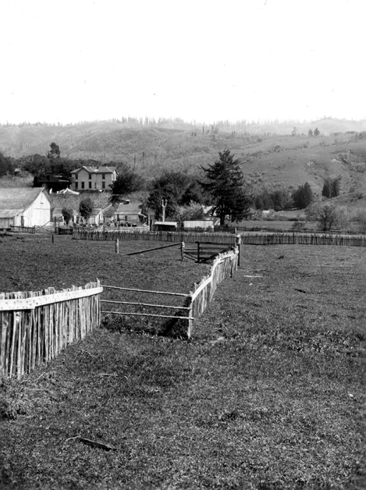
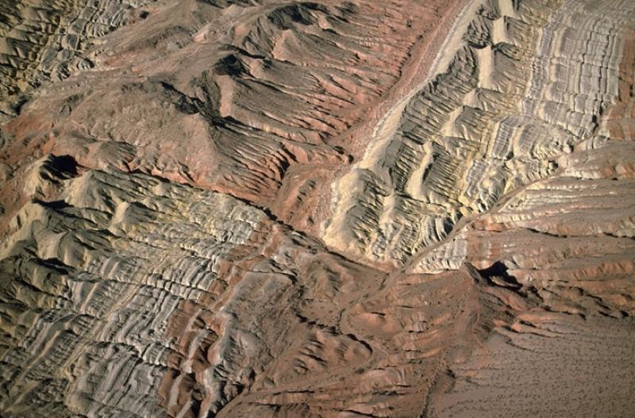

Photo 12.9 . Right-lateral fault, strike-slip (transform) fault, southern Nevada. View is approx. 1 km across. Beds and sense of offset are clearly revealed by surface weathering. Photo by M. Miller . GEOMORPH0000001387.
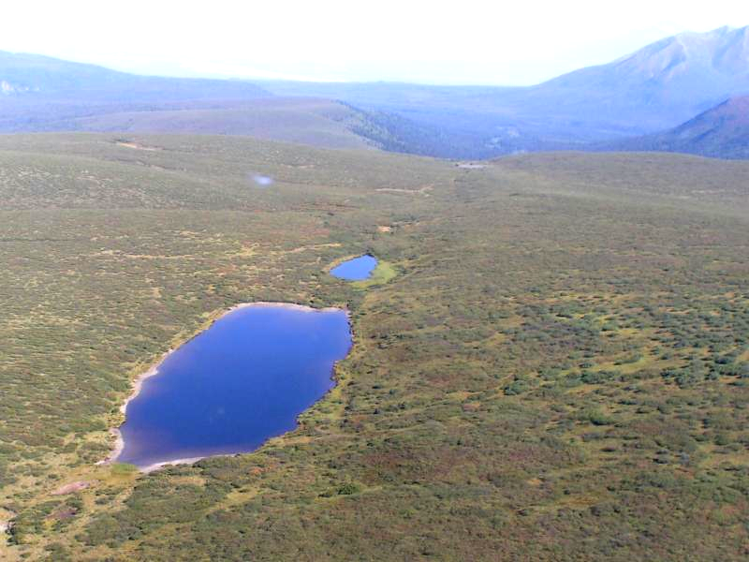
Photo 12.10 The Denali fault (Alaska) runs obliquely across this image; a line of sag ponds mark its trace. GEOMORPH0000000700. Photo by A. Matmon.

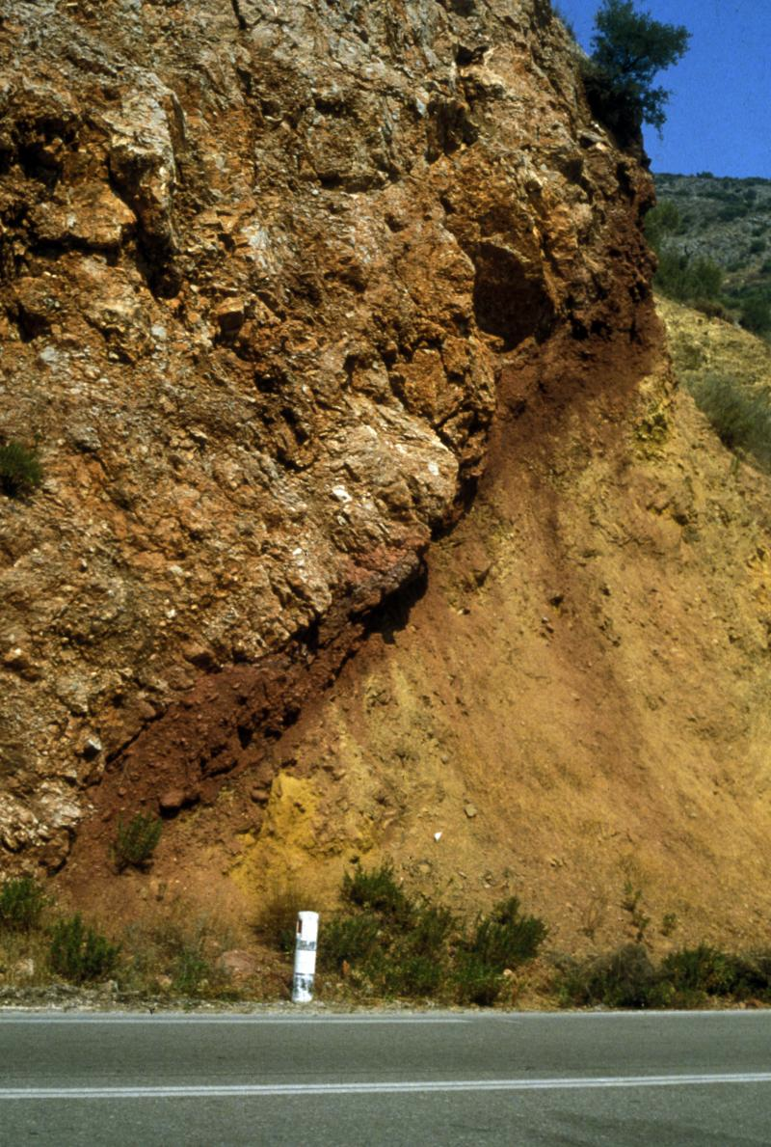
Photo 12.11. . Tertiary thrust fault in the northern Gulf of Corinth between Athens and Delphi. The unit below is clastic sedimentary rock. The unit above is fault mélange of the upper plate--also originally sedimentary material. GEOMORPH0000004128. Photo by R. Hazlett.
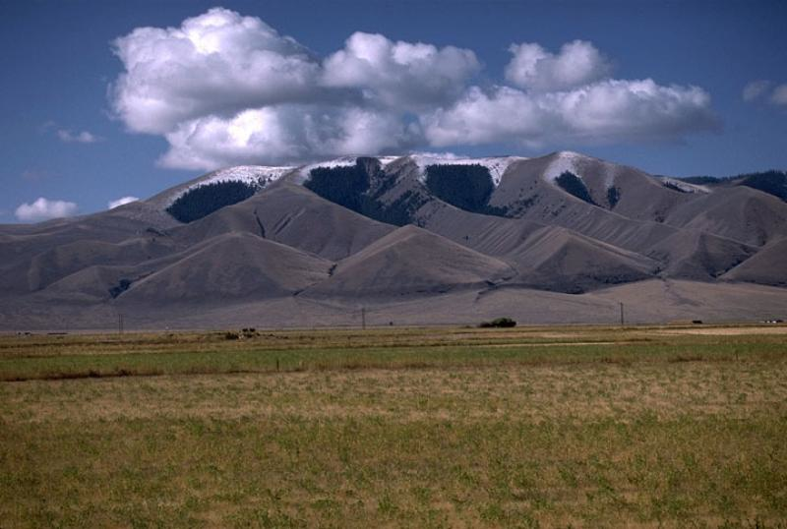
Photo 12.12 Triangular facets on range front from normal faulting at base of range. Tendoy Mountains., SW Montana. Photo by M. Miller. GEOMORPH0000001272.
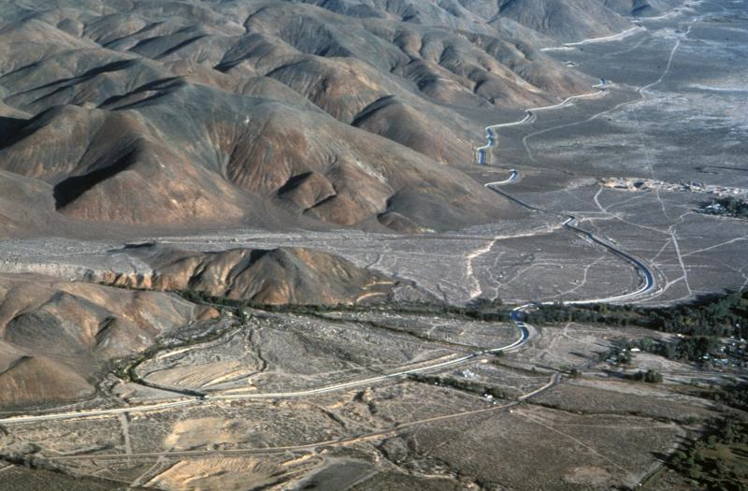

Photo 12.13. Lone Pine strand of the Owens Valley fault offsets late Pleistocene alluvial fan at the margin of the Alabama Hills, a fault block downdropped from the Sierra Nevada crest. The white fault scarp cuts across the Los Angeles aqueduct, which runs around the toe of the fan. Photo by P. Bierman. GEOMORPH0000000085. Comment: aqueduct, fan and scarp need labels.

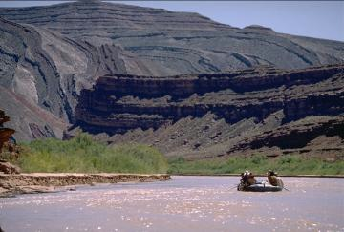 | 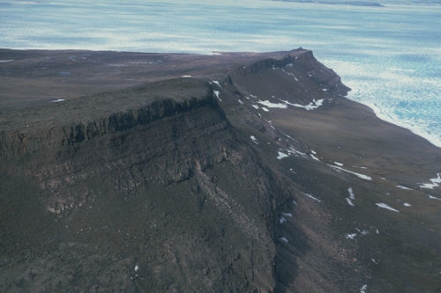
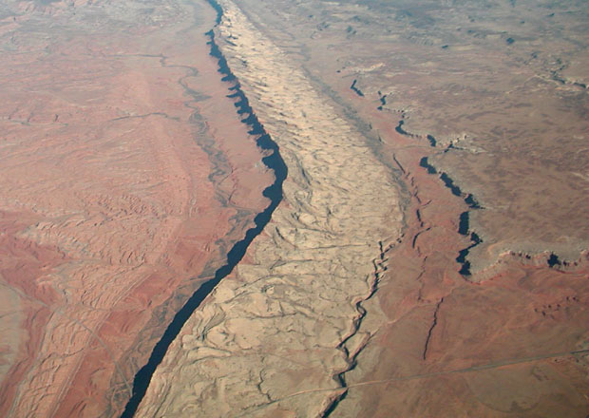 | 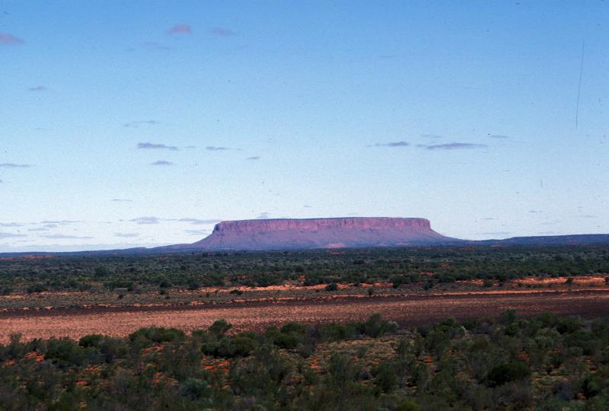
Photo 12.14 Structural landforms exposed by erosion. A. Monocline in southeastern SE Utah. Note low fluvial terrace on left and talus slope in distance. Photo by M. Miller GEOMORPH000000136. B) Cuesta is the steep escarpment to the right and the gentle slope extending to the left of the image, parallel to the dip of underlying sandstone. Northern end of Melville Peninsula, Canada. Photo by Geological Survey of Canada. http://gsc.nrcan.gc.ca/landscapes/details_e.php?photoID=745. C) Hogback of resistant rock in the Colorado Plateau. Photo by J. Zupancic from http://academic.emporia.edu/aberjame/field/rocky_mt/rocky.htm D) Mt. Connor, a mesa in the Northern Territory of Australia. Photo by P. Bierman. GEOMORPH0000000046.
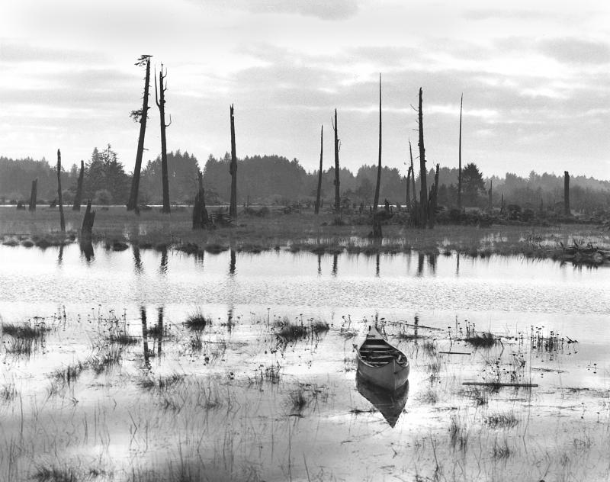

Photo 12.15. Ghost forest along the Copalis River, southwestern Washington. The dead trees, referred to as snags, were victims of tidal submergence caused by tectonic subsidence during the great, 1700 Cascadia subduction zone earthquake. They died when their roots were immersed in salt water. Photo by B. Atwater. GEOMORPH0000000300.
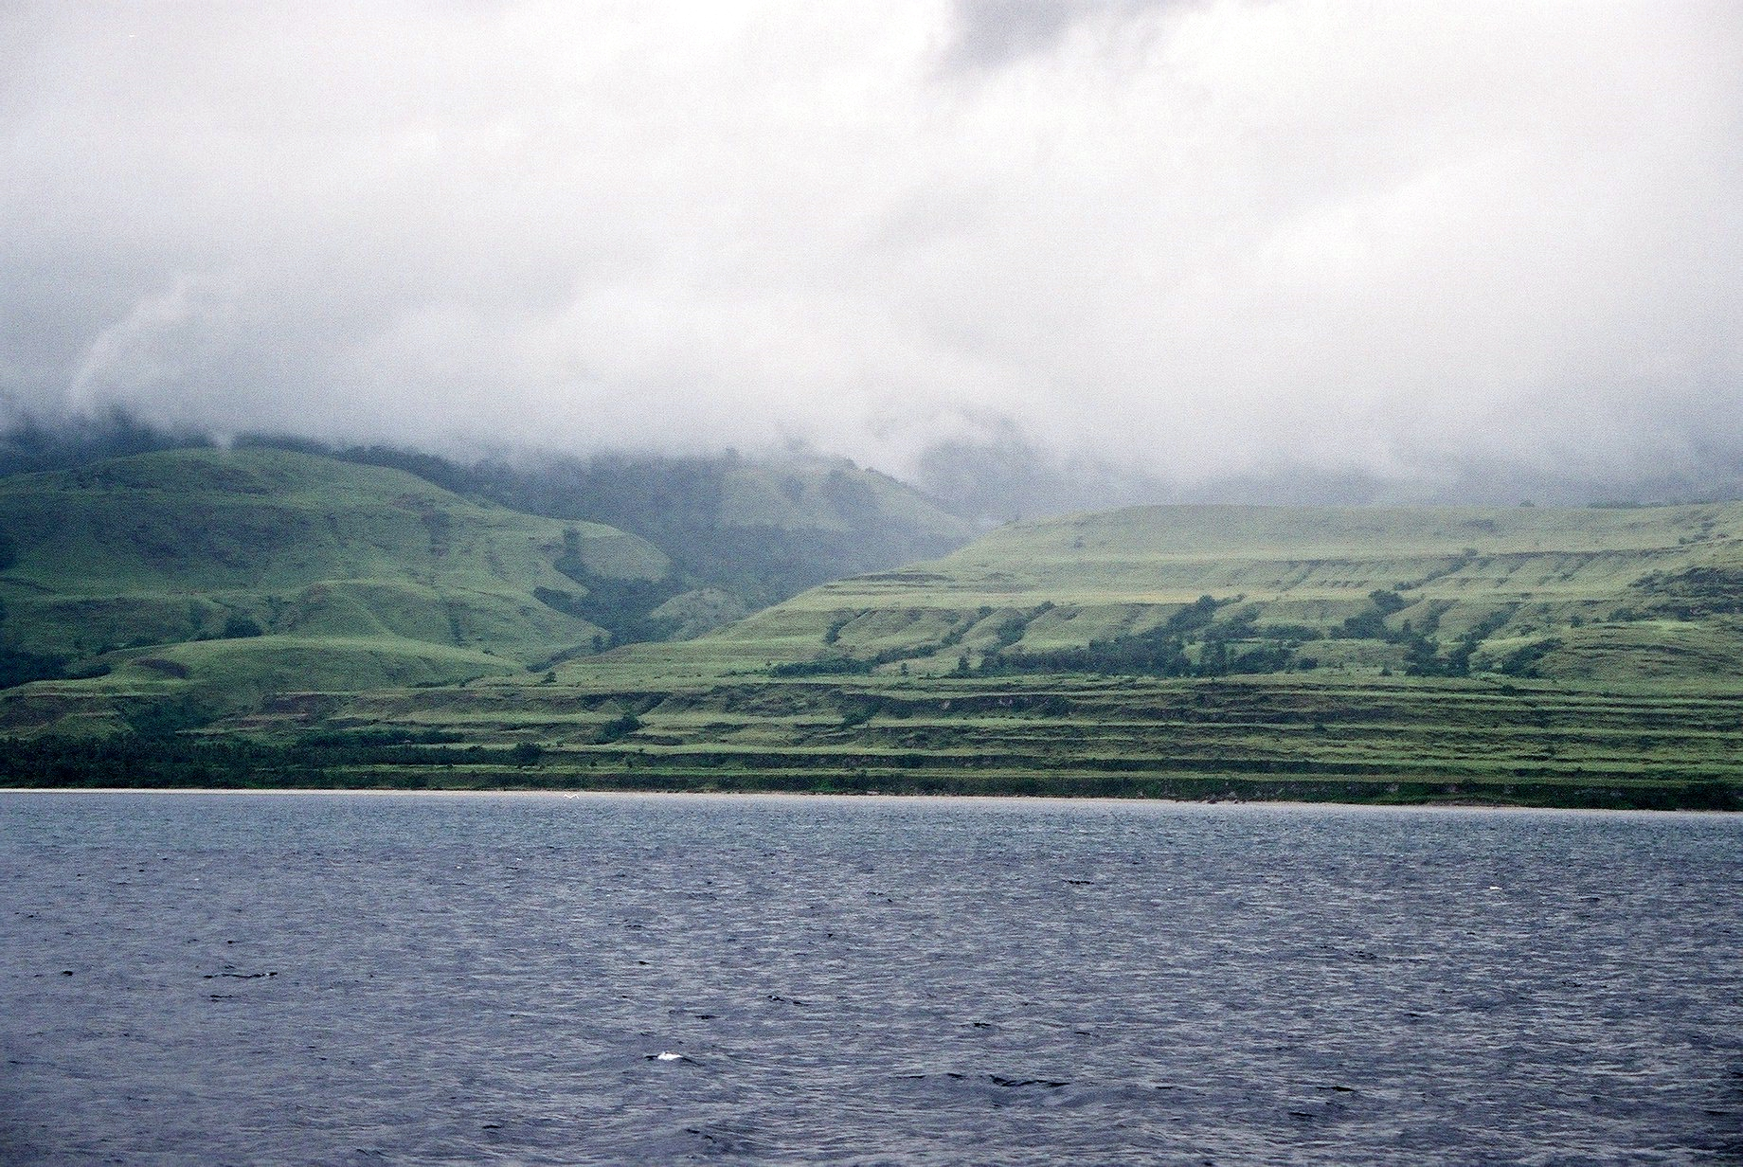

Photo 12.16 Flights of marine terraces on the rapidly uplifting Huon Peninsula of New Guinea. Photo by ARC Centre of Excellence. http://www.coralcoe.org.au/news_stories/fossilnino/imagegallery.html
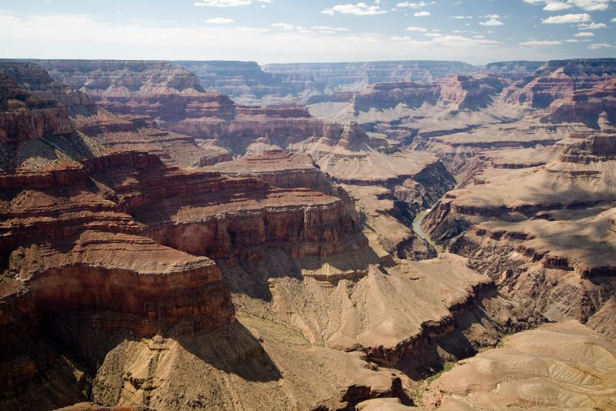
Photo 12.17 Inner gorge of the Colorado River as it cuts through rocks to form the Grand Canyon. GEOMORPH0000001137. Photo by L. Galuzzi.

Figures
Figure 1. Relationship between surface uplift and the uplift and exhumation of rocks.
Figure 2. Crustal plates have flexural strength that distributes the loading or unloading of material, resulting in far-field depressions and bulges.
Figure 3. Collisional tectonic settings: A) continental collisions typically have a major mountain range bordered by a foreland sedimentary basin; B) subduction zones consist of either oceanic island arcs or continental arcs.
Figure 4. Rift zones characterize extensional tectonic settings.
Figure 5. Characteristic landforms of strike-slip fault zones.
Figure 6. Interaction of strike-slip fault geometry and topography. Zones of structural uplift results from restraining bends whereas subsidence occurs in pull-apart bends.
Figure 7. Thrust faults form anticlinal ridges where deformed stream terraces may be used to investigate the history of uplift along the fault.
Figure 8. Characteristic landforms of normal fault zones.
Figure 9. The Basin and Range physiographic province of western North America is the product of east-west extension that broke a high-standing plateau into numerous north-south trending ranges.
Figure 10. The Himalaya and Tibet formed as a result of tectonic convergence as India rammed into Asia.
Figure 11. The valley and ridge morphology of the Appalachian Mountains reflects the strong influence of geological structure and lithology on the topography of tectonically inactive mountain ranges.
Figure 12. On an uplifting coastline, the elevation of marine terraces and inland bedrock strath terraces may be correlated with past sea level high stands to estimate their age.
Figure 13. Changing base level results in different river and sedimentary basin response.
Figure 14. Drainage area and slope are inversely related down river systems. Locations where the slope/area trend along a river diverges from the general trend can be used to estimate changes in rock uplift rate.

